

Requirement & Design Specification

**Coffee Shop**

**Version: 1.0**

– Hanoi, November 2025 –

# Record of Changes

| **Version** | **Date** | **A* M, D** | **In charge** | **Change Description** |
| --- | --- | --- | --- | --- |
|  | 09/11 | A | MINHNC | -Draw a Context Diagram and External Entities  -Develop Use Cases for Marketer and Guest  -Design the System Functionalities, including Screen Flow and Screen Authorization  -Revise Use Cases for Marketer and and Guest  -Add table Inventory to count product usage supporting the Status attribute in the Menu table.  The system follows a layered Java Web architecture: Filters → Servlet Controllers (JSP views) → Services → DAOs (JDBC), where JSP under WEB-INF/views renders the UI. The Service layer handles business logic and DTO/Entity mapping, while DAOs connect to Supabase PostgreSQL via JDBC; shared concerns (utilities, configuration, and error handling) are centralized in the common/config/exception modules. |
|  | 9/11 | A | DAIND | -Develop Use Cases for and Admin  - I updated the edit/detail setting pointer to the same jsp (SettingEdit.jsp), not showing the settingId in the table anymore. Updated the filter in SettingList, with clearer validation when adding a new setting. |
|  | 9/11 | A | ANHNQ | -Develop Use Cases for Guest and Admin  -Design the Sale & Marketing Process (Business Processes)  -Design the Functional Requirement Screens for (Login, Register, Password Reset, Password Change, Manage User Profile)  -Revise Use Cases for Customer |
|  |  |  |  |  |
|  |  |  |  |  |
|  |  |  |  |  |
|  |  |  |  |  |
|  |  |  |  |  |

*A - Added M - Modified D - Deleted

Contents

Record of Changes 2

I. Overview 5

1. System Context 5

2. External Entities 5

3. Business Processes 6

3.1 Sale & Marketing Processes 6

3.2 HR Processes 7

3.3 Finance Processes 7

4. User Requirements 8

4.1 UCs for Guest 11

4.2 UCs for Customer 12

4.3 UCs for Hr 13

4.4 UCs for Marketers 14

4.4 UCs for Cashier 15

4.5 UCs for Admin 16

5. System Functionalities 17

5.1 Screens Flow 17

5.2 Screen Authorization 17

5.3 Non-UI Functions 18

II. Functional Requirements 20

1. Home Screen 20

1.1 Home Page Screen 20

1.2 Product public Screen 22

1.3 Public Product details Screen 23

1.4 Manager Shopping Cart Screen 25

2. User Authentication 27

2.1 User Register 27

2.2 User Login 28

2.3 Password Reset 30

2.4 View My Orders 31

2.5 View My Orders 32

2.6 Manage User Profile 34

2.7 Password Change 35

3. System Administration 37

3.1 HR 37

3.2 Marketing 43

3.3 Cashier 50

3.4 Admin 53

III. System Design 59

1. Software Architecture 59

1.1 Overall Architectural Diagram 59

2. Code Package Design 60

2.1 Package Diagram 60

2.2 Package Descriptions 60

3. Database Design 63

3.1 Database Schema 63

3.2 Table Descriptions 63

# I. Overview

## 1. System Context

The Sale and Marketing System (SMS) is a new web-based information system developed to replace manual and disconnected processes for managing product sales, marketing activities, and customer interactions in coffee shop businesses. The context diagram below illustrates the external entities and system interfaces for the initial release of SMS, focusing on automating key operations such as user management, product catalog maintenance, order processing, and online payment through third-party services like PayOS. The system is expected to evolve over multiple releases, potentially integrating with external APIs for order, payment, and product synchronization, as well as expanding its capabilities to include advanced analytics, marketing automation, and multi-branch management support.

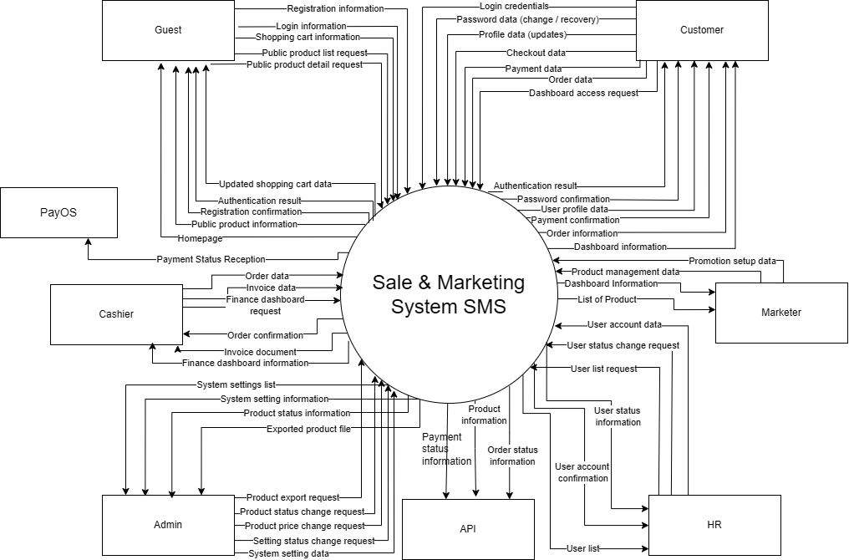

## 2. External Entities

| **#** | **Entity** | **Description** |
| --- | --- | --- |
| 1 | Guest | Guest users can browse the café’s homepage, view public products with details, and manage a temporary shopping cart. They can also register for a user account to gain full access to ordering and loyalty features. |
| 2 | Customer | Customers can log in using Google or email, reset their password, and manage their profile including changing passwords. They can also shop by checking out their cart, making online payments, viewing, updating, or canceling orders, and securely logging out of the system. |
| 3 | HR | HR users can access the HR dashboard to monitor activities, view the user list, and manage employee accounts. They can add new users, update user details, and activate or deactivate user accounts as needed. |
| 4 | Marketer | The marketer can access the Marketing Dashboard to track sales trends and product performance. They are able to view the product list, add new products, update product details, and activate or deactivate products as needed to support business goals. |
| 5 | Cashier | The cashier can access the Finance Dashboard to oversee financial transactions. They are responsible for creating new orders and generating order invoices to ensure accurate billing and payment processing. |
| 6 | Admin | The admin has full control of the system through the Admin Dashboard. They can manage users, products, orders, invoices, and system settings, including creating, updating, activating/deactivating, and deleting records. Additionally, the admin can oversee profiles, notifications, and security functions such as login, password reset, and profile updates. |

## 3. Business Processes

### 3.1 Sale & Marketing Processes

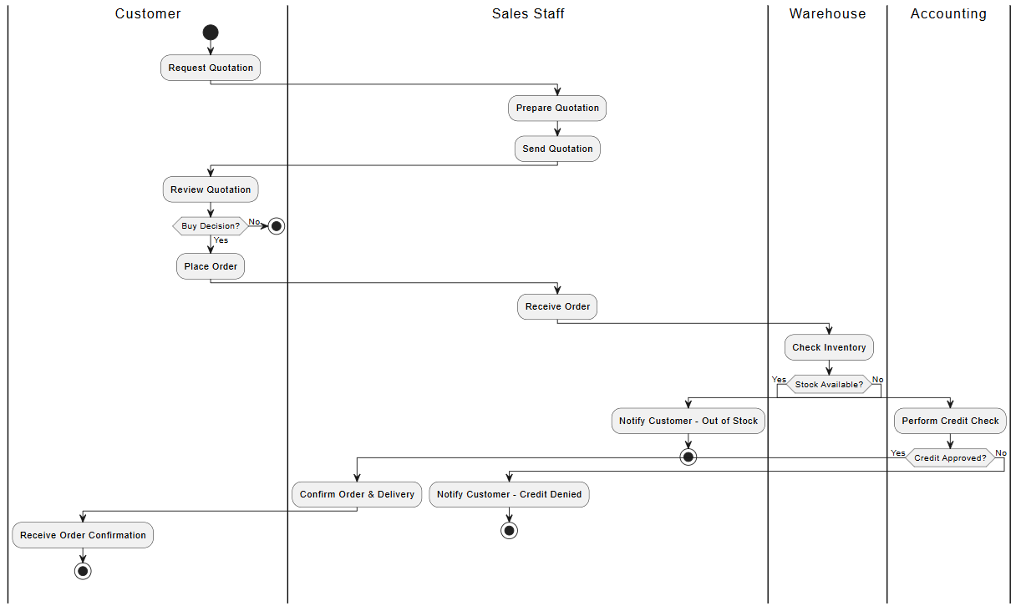

### 3.2 HR Processes

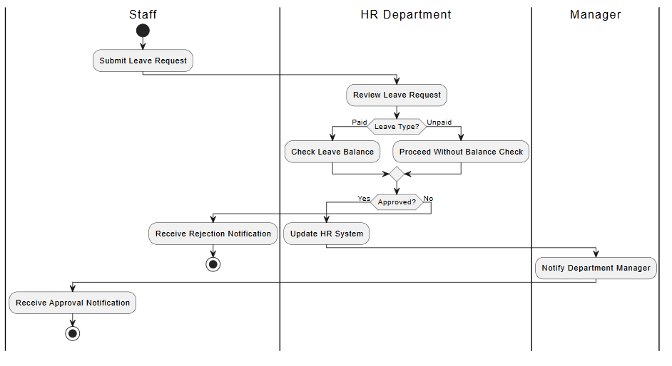

### 

### 

### 3.3 Finance Processes

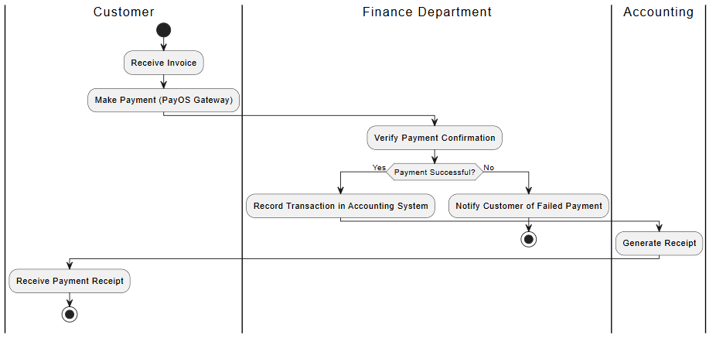

## 4. User Requirements

| **ID** | **Use Case** | **Feature** | **Main Actor** | **Use Case Description** |
| --- | --- | --- | --- | --- |
| 1 | View Home Page | View Home Page | Guest | Guests can access the home page to explore the general layout and key highlights of the website. The page provides an overview of available products, promotions, and navigation links, giving new visitors a welcoming first impression without requiring login. |
|  | Logout System | Logout System | Guest | Users can securely log out of the system to end their current session. This ensures account safety, especially on shared devices, by preventing unauthorized access after the user leaves. |
| 3 | View Public Product List | View Public Product List | Guest | Guests can view the public product list with basic information such as name, price, and image, and can navigate to each product’s detailed page if they want more information. |
| 4 | View Public Promotion List | View Public Promotion List | Guest | Guests can view the list of public promotions, including descriptions, validity periods, and basic conditions, to see which discounts are currently available. |
| 5 | Search & Filter Public Products | Search & Filter Public Products | Guest | Guests can search for products by keyword and filter them by category or status to quickly find items that match their interests without logging in. |
| 6 | Search & Filter Public Promotions | Search & Filter Public Promotions | Guest | Guests can search and filter promotions by type, category, or status to easily locate the most relevant offers before making a purchase decision. |
| 7 | Login | Login | Guest | Guests enter their email/username and password to sign in to the system. After successful authentication, they are granted access according to their assigned role (Customer, HR, Marketer, Cashier, Admin). |
| 8 | Login with Google | Login with Google | Guest | Guests can log in using their Google account for a faster sign-in experience. The system retrieves basic profile information and creates or links an internal account as needed. |
| 9 | Register Account | Register Account | Guest | Guests can register a new account by filling in a sign-up form with personal details, email, and password, and then confirming the terms of use to become a registered customer. |
| 10 | Forgot Password | Forgot Password | Guest | Guests who forget their password can request a reset. The system sends an OTP or reset link via email so they can securely set a new password. |
| 11 | Manage Profile | Manage Profile | Customer | Customers can view and update their personal profile information such as full name, phone number, delivery address, and avatar so that their account data remains accurate. |
| 12 | Change Password | Change Password | Customer | Customers can change their login password by entering the current password and a new one, improving the security of their account. |
| 13 | View My Orders | View My Orders | Customer | Customers can view a list of their past and current orders, including order codes, dates, payment status, and delivery status, to track their purchase history. |
| 14 | View My Order Details | View My Order Details | Customer | Customers can open a specific order to see detailed information such as product items, quantities, prices, applied promotions, delivery address, and payment method. |
| 15 | Manage Shopping Cart | Manage Shopping Cart | Customer | Customers can manage the current shopping cart: view items, update quantities, remove items, and prepare the cart for checkout. |
| 16 | Add Item to Cart | Add Item to Cart | Customer | Customers can add products to their cart from the product list or product detail page by selecting a quantity and confirming the addition. |
| 17 | Checkout | Checkout | Customer | Customers go through the checkout process: review items, confirm quantities and prices, provide delivery information, optionally apply a promotion code, and proceed to payment. |
| 18 | Select Payment Method | Select Payment Method | Customer | During checkout, customers choose a payment method (cash on delivery or online payment via PayOS) so the order can be processed with the appropriate payment workflow. |
| 19 | Pay with Cash | Pay with Cash | Customer | Customers choose the cash payment option. The system records the order as “Cash on Delivery,” and payment will be collected when the order is delivered or at the store. |
| 20 | Pay with PayOS | Pay with PayOS | Customer | Customers pay online via the PayOS gateway. The system creates a payment link, redirects the customer to PayOS, receives the payment result, and updates the order status accordingly.d recently created users. |
| 21 | View HR Dashboard | View HR Dashboard | HR | HR staff can view an HR dashboard showing user statistics such as total users, users by role, active/inactive accounts, and recently created users. |
| 22 | Create New User | Create New User | HR | HR staff can create new user accounts (e.g., Admin, HR, Marketer, Cashier, Customer) by filling out a user form and assigning appropriate roles and statuses. |
| 23 | Update User | Update User | HR | HR staff can update existing user accounts by editing profile data, role assignments, or status values to keep user information up to date. |
| 24 | View User List | View User List | HR | HR staff can see the full list of users in the system, then search, filter, and sort the list to find specific accounts efficiently. |
| 25 | View User Details | View User Details | HR | HR staff can open a specific user record to see detailed information, including contact details, role, status, and other relevant attributes. |
| 26 | Search Users | Search Users | HR | HR staff can search for users by name, email, or keyword to quickly locate a specific account for review or editing. |
| 27 | Filter & Sort Users | Filter & Sort Users | HR | HR staff can filter users by role or status and sort them by name, creation date, or other criteria to better organize the user list. |
| 28 | Toggle User Status | Toggle User Status | HR | HR staff can change a user’s status (Active, Inactive, Blocked) to grant or revoke access to the system when necessary. |
| 29 | View Marketer Dashboard | View Marketer Dashboard | Marketer | Marketers can access a marketing dashboard that summarizes key indicators such as product statistics, distribution by category, status charts, and recent products. |
| 30 | Create New Product | Create New Product | Marketer | Marketers can create a new product by filling in a product form with name, price, description, stock quantity, image, and category, then saving it to the catalog. |
| 31 | Update Product | Update Product | Marketer | Marketers can update existing product information such as price, description, image, stock quantity, or category to keep the catalog accurate. |
| 32 | View Product List | View Product List | Marketer | Marketers can view the internal product list, then search, filter by category or status, and sort products to manage the catalog efficiently. |
| 33 | View Product Details | View Product Details | Marketer | Marketers can view detailed information for a specific product, including attributes and any related configuration, before deciding on updates or promotions. |
| 34 | Toggle Product Status |  | Marketer | Marketers can enable or disable a product (e.g., Active/Inactive/Hidden) to control whether it appears in customer-facing product lists. |
| 35 | Create New Promotion |  | Marketer | Marketers can create new promotion campaigns by selecting target products, defining discount rules, setting validity periods, and specifying usage conditions. |
| 36 | Update Promotion |  | Marketer | Marketers can edit existing promotions to adjust discount amounts, time ranges, targeted products, or conditions based on business needs. |
| 37 | View Promotion List | View Promotion List | Marketer | Marketers can view a list of all promotions in the system and use search, filter, and sort options to locate specific campaigns. |
| 38 | View Promotion Details | View Promotion Details | Marketer | Marketers can open a specific promotion to see detailed information such as applied products, discount type, conditions, and validity period. |
| 39 | Toggle Promotion Status | Toggle Promotion Status | Marketer | Marketers can activate or deactivate promotions to control whether they are applied during checkout or shown in customer interfaces. |
| 40 | Search & Filter Products | Search & Filter Products | Marketer | Marketers can search and filter products by keyword, category, or status to quickly select items for promotion or catalog management. |
| 41 | Search & Filter Promotions | Search & Filter Promotions | Marketer | Marketers can search and filter promotions by name, type, or status to evaluate, compare, and manage ongoing or past campaigns. |
| 42 | View Cashier Dashboard | View Cashier Dashboard | Cashier | Cashiers can view a cashier dashboard summarizing today’s orders, today’s revenue, order counts by status, and a list of recent orders. |
| 43 | Create Order | Create Order | Cashier | Cashiers can create new dashboard, choosing products, entering quantities, applying available promotions, text note. View the total and payment amount. |
| 44 | Update Order | Update Order | Cashier | Cashiers can modify an order that has not yet been finalized, adjusting products, quantities, or promotion and add text notes. |
| 45 | Confirm Order | Confirm Order | Cashier | Cashiers confirm the order after payment is received and printf invoice. The system stores the order as completed. |
| 46 | View Order List | View Order List | Cashier | Cashiers can view the list of orders and use search by status and time filter for quick lookup. |
| 47 | View Order Details | View Order Details | Cashier | Cashiers can open an order to see full details, including product items, prices, applied promotions, payment method, and customer information . |
| 49 | View Admin Dashboard | View Admin Dashboard | Admin | Admins can access an admin dashboard showing an overall view of the system, including counts of users, products, orders, promotions, and high-level statistics. |
| 50 | View System Statistics | View System Statistics | Admin | Admins can view detailed system reports that aggregate data by users, products, orders, and promotions to evaluate business performance and system usage. |
| 51 | View Settings Statistics | View Settings Statistics | Admin | Admins can view statistics related to system settings, such as the number of settings by group or status, to understand configuration coverage. |
| 52 | Create New Setting | Create New Setting | Admin | Admins can create new system settings (e.g., global parameters, limits, display options) by filling in a setting form with key, value, type, and description. |
| 53 | Update Setting | Update Setting | Admin | Admins can change existing settings—such as shipping fee, free-shipping threshold, or email configuration—so that the system behavior matches current policies. |
| 54 | View Setting List | View Setting List | Admin | Admins can view the full list of settings and then search, filter, or sort them to locate specific configuration entries. |
| 55 | View Setting Details | View Setting Details | Admin | Admins can open a single setting to see its key, current value, description, category, and other metadata before making changes. |
| 56 | Toggle Setting Status | Toggle Setting Status | Admin | Admins can enable or disable individual settings (Active/Inactive) to control whether a given configuration is currently applied in the system. |
| 57 | Search & Filter Settings | Search & Filter Settings | Admin | Admins can search settings by key or name and filter by group or status, making it easier to maintain large numbers of configuration entries. |
| 58 | Sort Settings | Sort Settings | Admin | Admins can sort settings by name, category, creation date, or other fields to improve readability and make configuration management more convenient. |

## 

### 4.1 UCs for Guest

## 

| Admin |
| --- |

## 

### 4.2 UCs for Customer

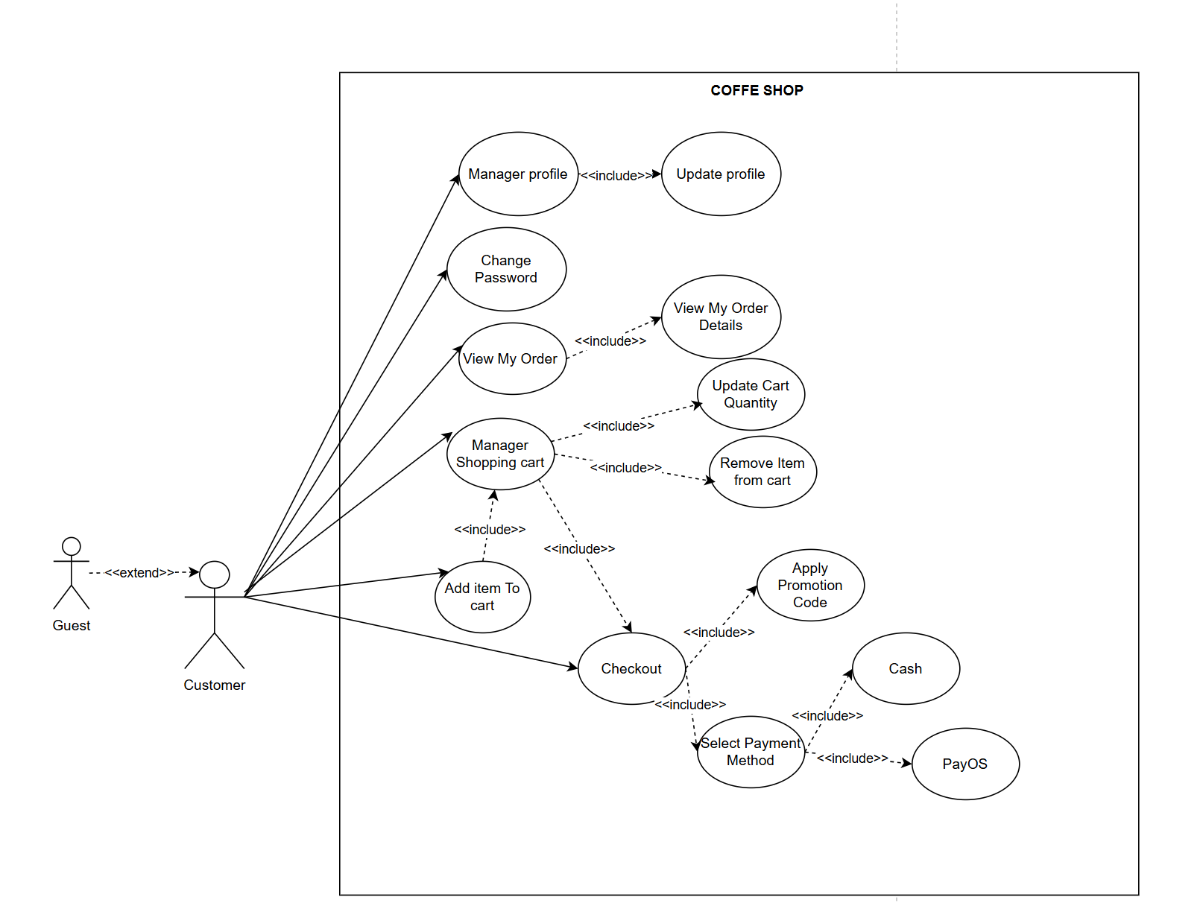

### 4.3 UCs for Hr

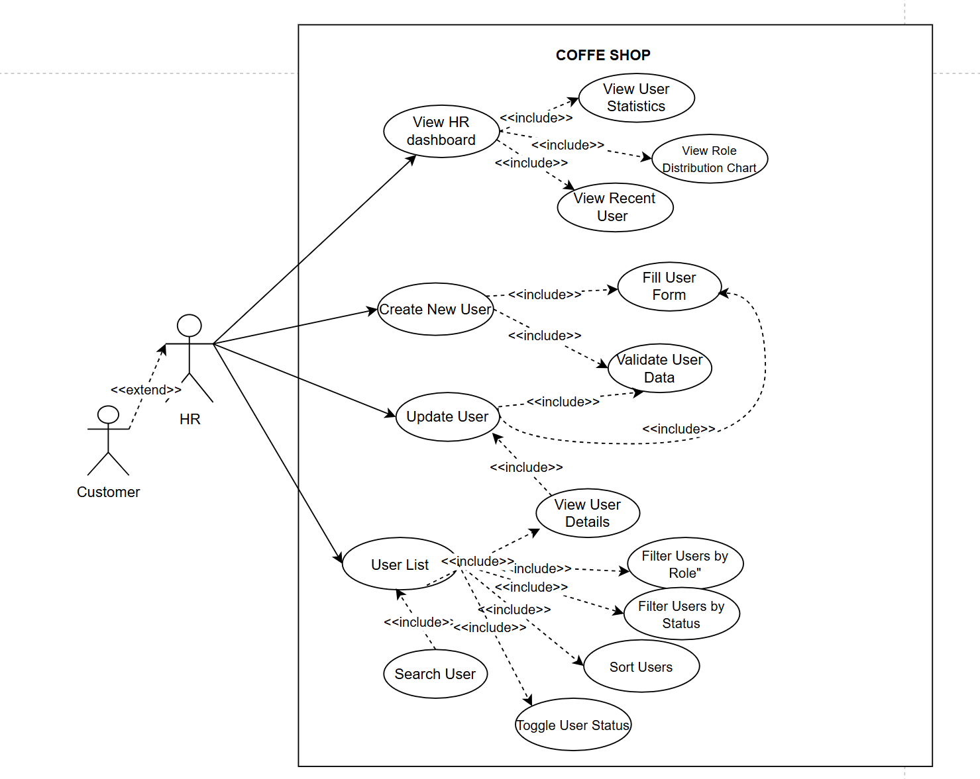

### 4.4 UCs for Marketers

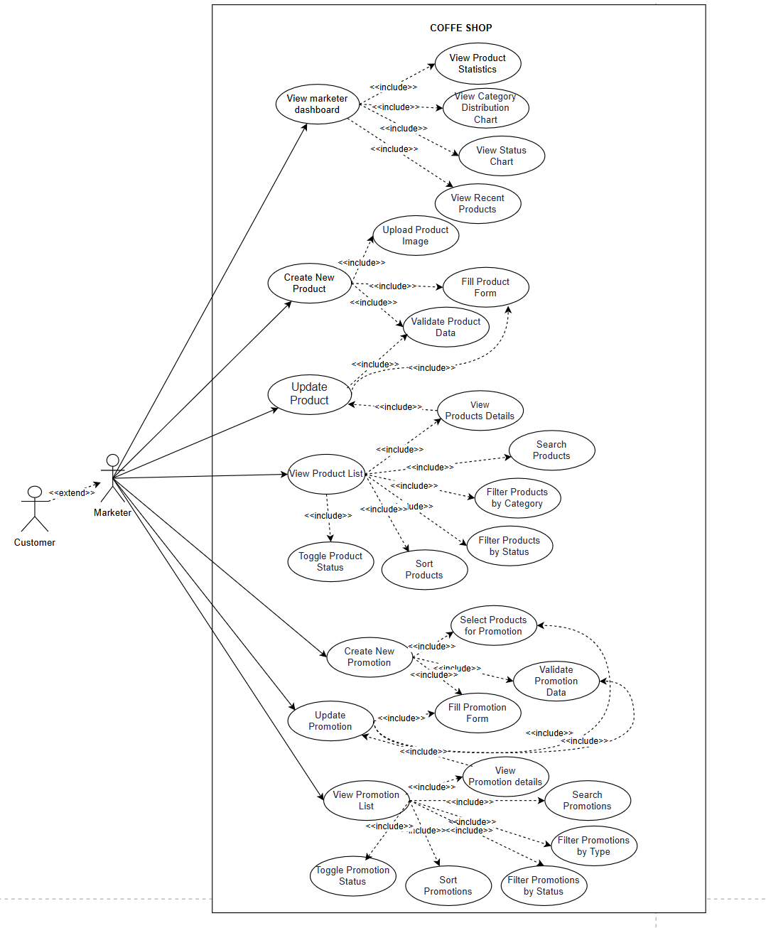

### 4.4 UCs for Cashier

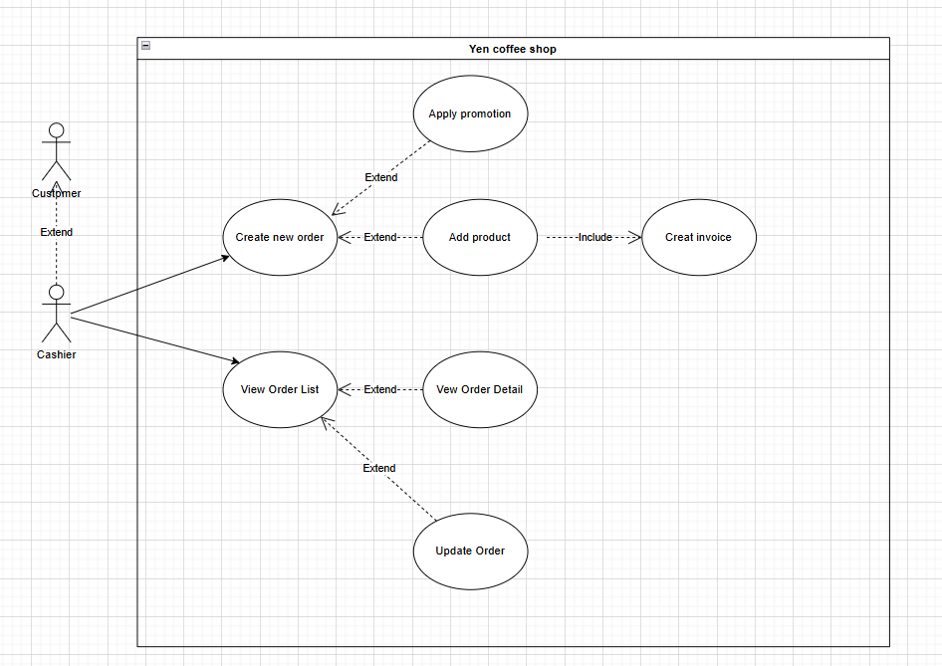

### 4.5 UCs for Admin

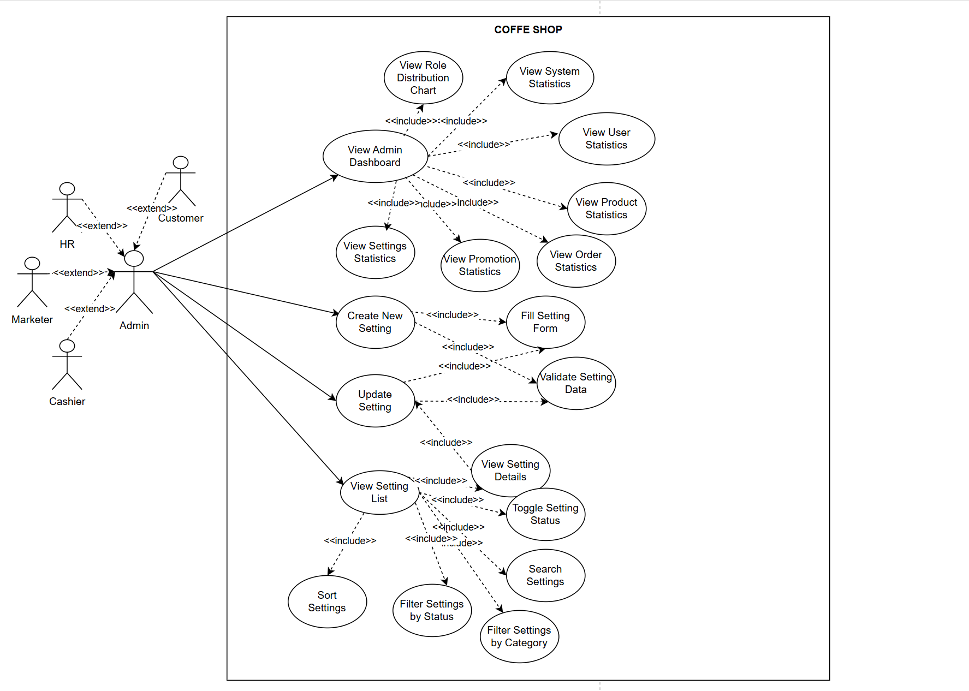

## 5. System Functionalities

### 5.1 Screens Flow

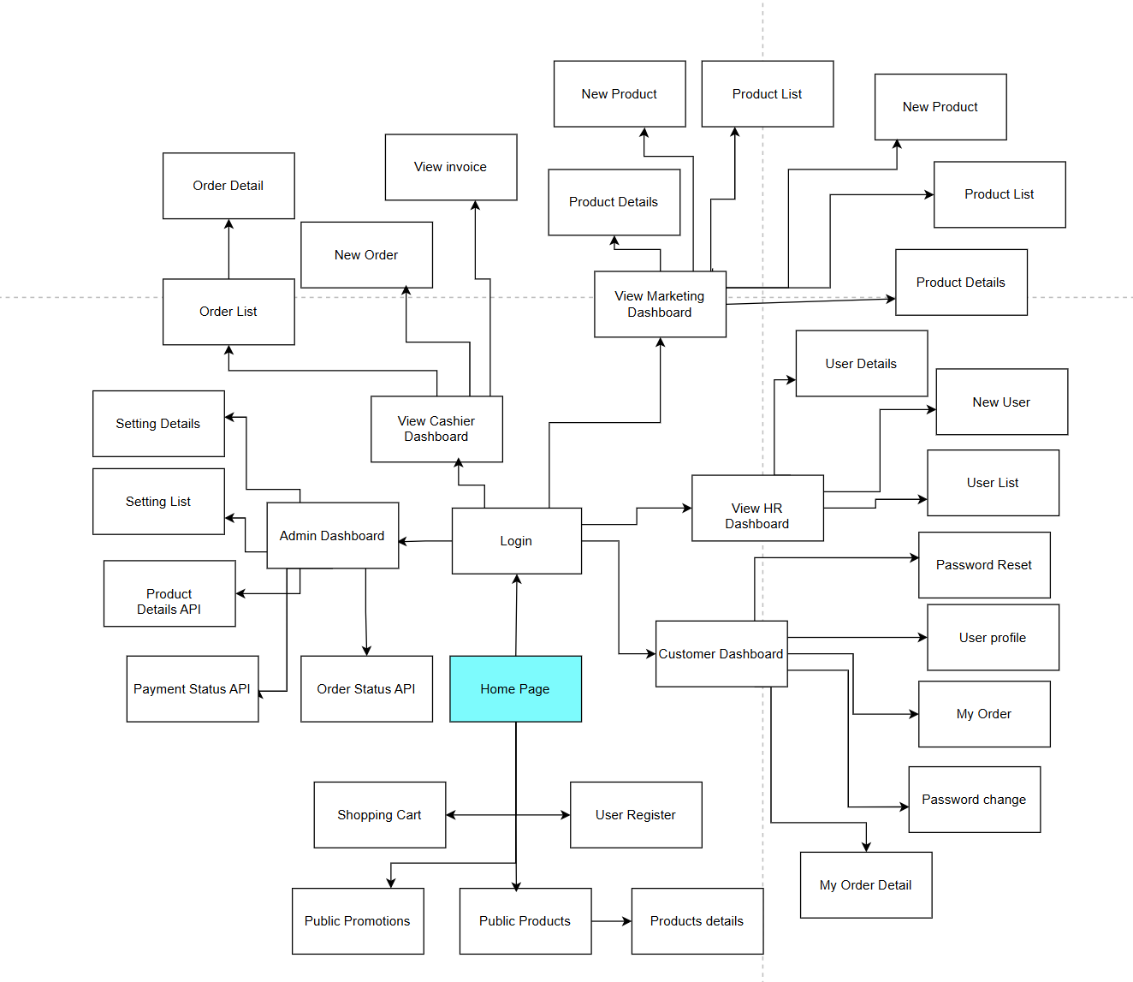

### 5.2 Screen Authorization

| **Screen** | **Guest** | **Customer** | **HR** | **Marketer** | **Admin** | **Cashier** |
| --- | --- | --- | --- | --- | --- | --- |
| Home Page | X | X | X | X | X | X |
| User Register | X |  |  |  |  |  |
| Login | X | X | X | X | X | X |
| Logout System | X | X | X | X | X | X |
| Public Products | X | X | X | X | X | X |
| Product Details (Public) | X | X | X | X | X | X |
| Public Promotion |  | x | x | x | x | x |
| Shopping Cart |  | X | x | x | x | x |
| Password Reset |  | X | x | x | x | x |
| User Profile |  | X | X | X | X | X |
| Password Change |  | X | X | X | X | X |
| My Orders |  | X | X | X | X | X |
| My Order Detail |  | X | X | X | X | X |
| View HR Dashboard |  |  | X |  |  |  |
| User List |  |  | X |  | X |  |
| User Details |  |  | X |  | X |  |
| New User |  |  | X |  | X |  |
| View Marketing Dashboard |  |  |  | X |  |  |
| Product List |  |  |  | X | X |  |
| Product Details |  |  |  | X | X |  |
| New Product |  |  |  | X | x |  |
| Promotion List |  |  |  | x | x |  |
| Promotion Details |  |  |  | x | x |  |
| New Promotion |  |  |  | x | x |  |
| View Cashier Dashboard |  |  |  |  |  | X |
| New Order |  |  |  |  | X | X |
| Order List |  |  |  |  | X | X |
| Order Details |  |  |  |  | X | X |
| Admin Dashboard |  |  |  |  | X |  |
| Setting List |  |  |  |  | X |  |
| Setting Details |  |  |  |  | X |  |
| Setting New |  |  |  |  |  |  |

### 5.3 Non-UI Functions

| **#** | **Feature** | **System Function** | **Description** |
| --- | --- | --- | --- |
| 1 | Product Details API | Receive Product Details | API function that provides external systems with product information (name, price, availability). |
| 2 | Payment Status API | Receive Payment Status | API function that communicates payment status updates (success, pending, failed) to external systems. |
| 3 | Order Status API | Receive Order Status | API function that provides external systems with order tracking information (status, delivery progress). |
| 4 | User Authorization | Authorize User | Background service that validates and authorizes user credentials before granting access to system features. |

# II. Functional Requirements

## 1. Home Screen

### 1.1 Home Page Screen

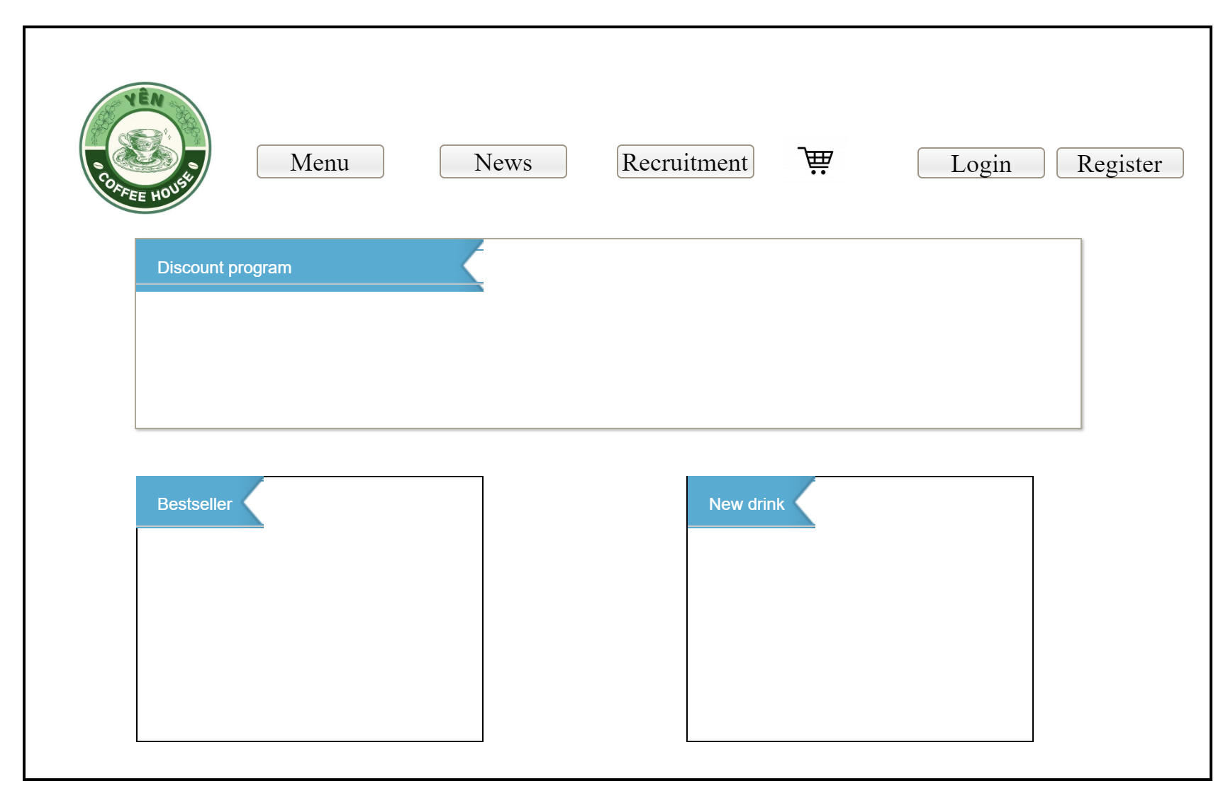

**This screen allows the Guest to:**

* View the company/store **Logo** on the top-left corner.
* Navigate through the **Main Menu** with options: **Menu, News, Recruitment, Cart, Login, Register**.
* View the **Promotion Banner** that highlights the current promotional program (**“Discount program”**).
* Explore featured sections: **Bestseller** and **New drink**.

**On the screen, s/he can also**

* Click on **Menu, News, Recruitment** to go to the corresponding pages.
* Access the shopping cart by clicking the **cart icon**.
* Start authentication by selecting **Login** or **Register**.
* Open the **Bestseller** or **New drink** panels to see their product lists.
* See promotional campaigns displayed in the **banner** area.

**Field Description**

| **Field Name** | **Description** |
| --- | --- |
| (1) Logo | Displays the Coffee Shop’s branding and serves as a quick link back to the home page (optional). |
| (2) Main Menu | Provides navigation links: Menu, News, Recruitment, Cart, Login, Register. |
| (3) Promotion Banner | Displays current promotions (e.g., “Discount program”). |
| (4) Bestseller Panel | Highlights top-selling items; clicking opens the bestseller list/detail. |
| (5) New Drink Panel | Highlights newly released beverages; clicking opens the new-drink list/detail. |
| (6) Cart Icon | Shortcut to the shopping cart page. |
| (7) Login / Register | Entry points for authentication and account creation. |

### 1.2 Product public Screen

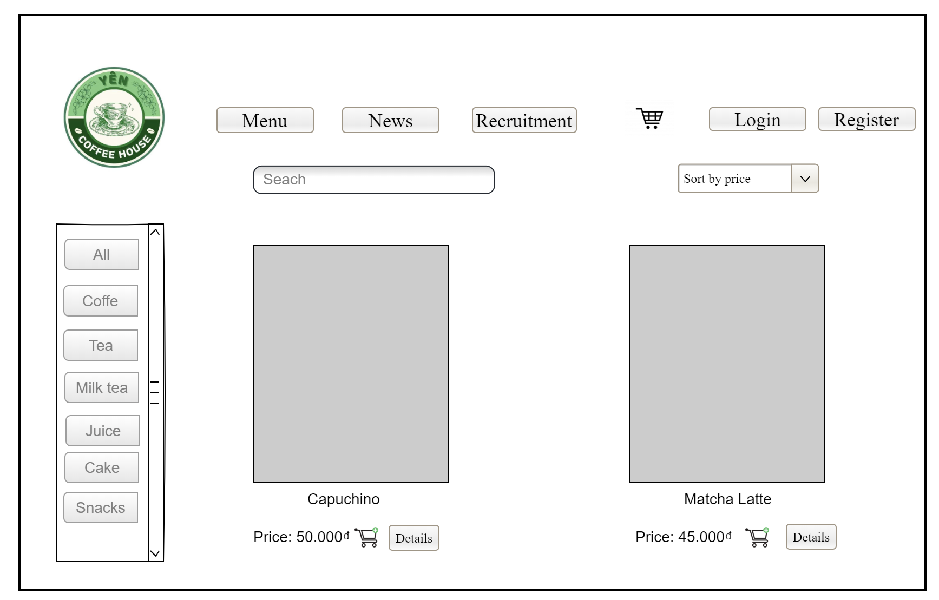

**This screen allows the Guest to:**

* View the company/store Logo on the top-left corner.
* Navigate through the Main Menu with options: *Menu, News, Recruitment, Cart, Login, Register*.
* Search for products using the Search Box.
* Filter products by categories on the left panel (All, Coffee, Tea, Milk tea, Juice, Cake, Snacks).
* Sort the displayed products using the “Sort by Price” dropdown.
* View product cards showing image, name, price, and action buttons.

**On the screen, s/he can also:**

* Click “Details” to view product details.
* Add products directly to the Shopping Cart by clicking the cart icon.
* Access more products by scrolling through categories or searching.
* Start authentication by selecting *Login* or *Register*.

**Field Description**

| **Field Name** | **Description** |
| --- | --- |
| (1) Logo | Display Coffee Shop's branding. |
| (2) Main Menu | Provides navigation links: Menu, News, Recruitment, Cart, Login, Register. |
| (3) Search Box | Input field where users can enter keywords to search for products. |
| (4) Category List | Sidebar for filtering products by type (e.g., Coffee, Tea, Milk tea, etc.). |
| (5) Sort Dropdown | Allows sorting products (e.g., by price). |
| (6) Product Card | Displays product info: name, price, image, and actions (Details, Add to Cart). |
| (7) Cart Icon | Shortcut to access the Shopping Cart. |

#### 

### 1.3 Public Product details Screen

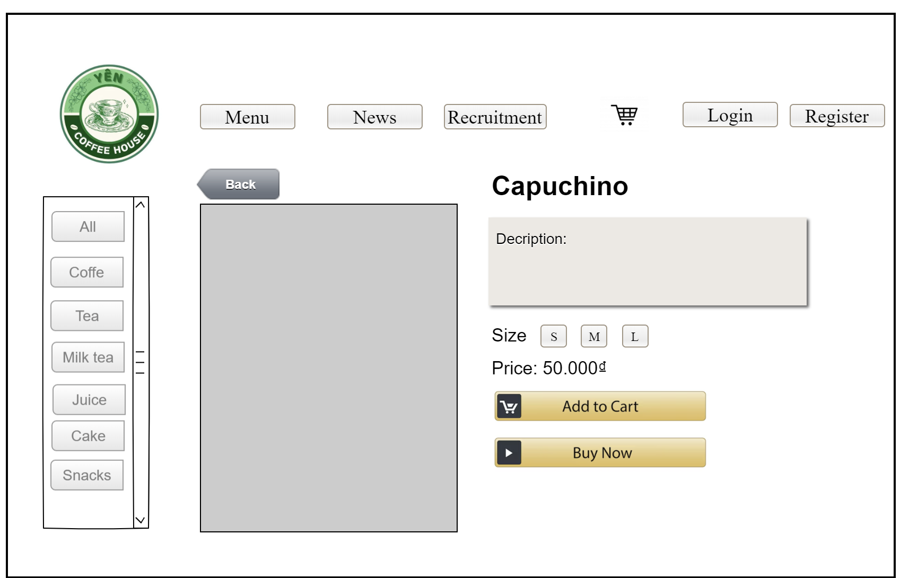

**This screen allows the Guest/Customer to:**

* View the company/store Logo on the top-left corner.
* Navigate through the Main Menu with options: Menu, News, Recruitment, Cart, Login, Register.
* Use the Category Filter on the left sidebar (All, Coffee, Tea, Milk Tea, Juice, Cake, Snacks) to switch product categories.
* View detailed information about a selected product (e.g., Capuchino).
* Read the product Description to understand its contents or features.
* Select the Size of the drink (S, M, L) before purchase.
* View the product Price displayed clearly.

**On the screen, s/he can also:**

* Click **Back** to return to the product listing page.
* Click **Add to Cart** to add the selected product to their shopping cart.
* Click **Buy Now** to proceed directly to checkout.

**Field Description**

| **Field Name** | **Description** |
| --- | --- |
| (1) Logo | Display Coffee shop’s branding. |
| (2) Navigation Bar | Provides navigation links: Menu, News, Recruitment, Cart, Login, Register. |
| (3) Category Filter | Sidebar with categories (All, Coffee, Tea, Milk Tea, Juice, Cake, Snacks) for product filtering. |
| (4) Product Image | Visual representation of the selected product. |
| (5) Product Name | Displays the name of the product (e.g., Capuchino). |
| (6) Description | Text area showing product description/details. |
| (7) Size Selector | Options to choose product size (S, M, L). |
| (8) Price | Displays the unit price of the selected product (e.g., 50,000₫). |
| (9) Back Button | Allows users to return to the product list page. |
| (10) Add to Cart | Button to add the product into the shopping cart for later checkout. |
| (11) Buy Now | Button to immediately proceed with checkout for the selected product. |

### 1.4 Manager Shopping Cart Screen

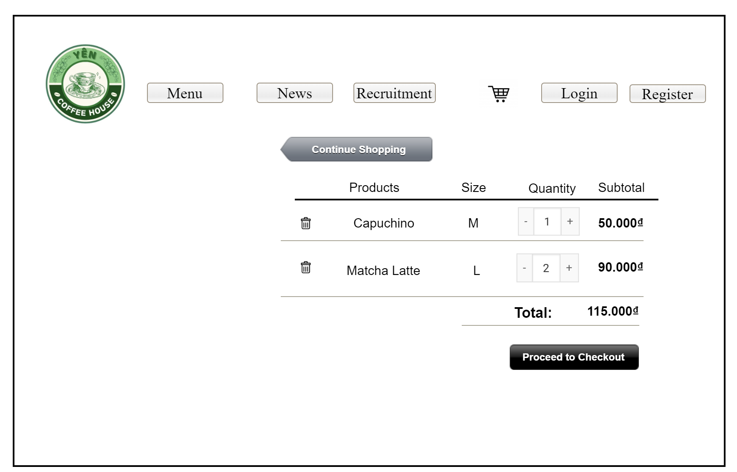

**This screen allows the Guest/Customer to:**

* View a list of selected products in the shopping cart.
* See product details including name, selected size, quantity, and subtotal price.
* Check the overall **Total** amount of the cart.
* Update the quantity of each product using “+” and “–” buttons.
* Remove items from the cart by clicking the **delete** icon.
* Continue shopping by clicking the **Continue Shopping** button.
* Proceed to checkout by clicking the **Proceed to Checkout** button.

**On the screen, s/he can also:**

* Navigate to other main menu pages (Menu, News, Recruitment).
* Log in or register before checkout if not authenticated.
* Access the shopping cart icon from the navigation bar.

**Field Description**

| **Field Name** | **Description** |
| --- | --- |
| (1) Logo | Display Coffee Shop's branding. |
| (2) Navigation Bar | Provides navigation links: Menu, News, Recruitment, Cart, Login, Register. |
| (3) Continue Shopping | Button to return to the product menu for adding more items. |
| (4) Product List | Displays products in the cart (Product name, size, quantity, price). |
| (5) Size | Shows the selected size of the product (e.g., S, M, L). |
| (6) Quantity Control | Allows users to adjust product quantity using “+” and “–”. |
| (7) Subtotal | Displays the subtotal for each product (price × quantity). |
| (8) Total | Displays the total price of all items in the cart. |
| (9) Delete Icon | Allows users to remove an item from the cart. |
| (10) Checkout Button | Proceeds to the checkout page. |

#### 

## 

## 2. User Authentication

### 2.1 User Register

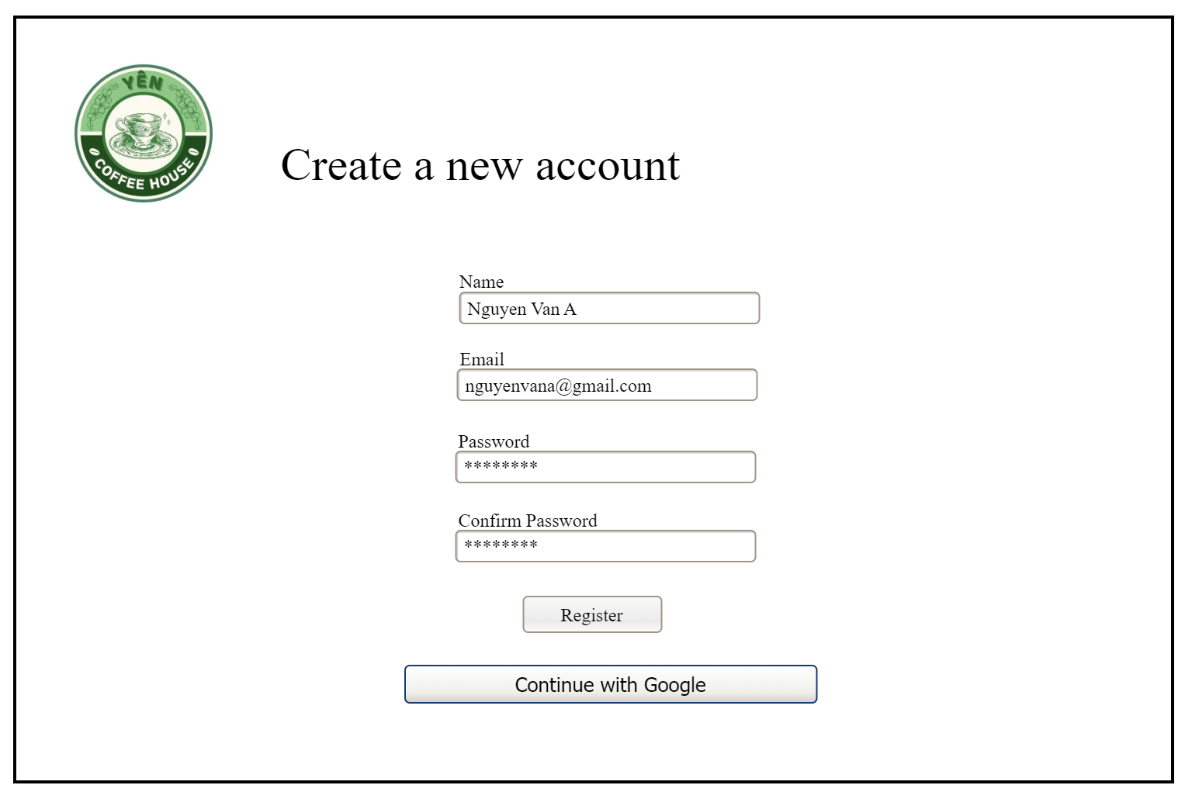

**This screen allows the Guest to:**

* View the company/store Logo on the top-left corner for branding and navigation.
* Create a new account by filling in personal details such as **Name, Email, Password, Confirm Password**.
* Authenticate either by completing the registration form or by using **Continue with Google** for faster sign-up.

**On the screen, s/he can also:**

* Enter required credentials into text input fields.
* Confirm password correctness by re-typing in the **Confirm Password** field.
* Click the **Register** button to create a new account.
* Choose the **Continue with Google** option to register using Google authentication.

**Field Description**

| **Field Name** | **Description** |
| --- | --- |
| (1) Logo | Displays Coffee Shop’s branding and serves as a quick navigation button. |
| (2) Name Field | Input field where users enter their full name. |
| (3) Email Field | Input field for entering a valid email address. |
| (4) Password Field | Secure field for entering a new password (masked characters). |
| (5) Confirm Password | Input field to re-enter password for confirmation. |
| (6) Register Button | Submits the form to create a new account. |
| (7) Continue with Google | Provides an option to sign up quickly using a Google account. |

#### 

### 2.2 User Login

**This screen allows the Guest/Customer to:**

* View the company/store Logo on the top-left corner for branding and navigation.
* Log into the system by entering their **Email** and **Password**.
* Use the **Remember me** checkbox to stay logged in across sessions.
* Authenticate either with the **Login button** or with **Continue with Google** for faster login.

**On the screen, s/he can also:**

* Recover access by clicking **Forgot your Password** to initiate the password reset process.
* Create a new account by selecting **Register as a new user** if not already registered.
* Quickly log in through Google authentication.

**Field Description**

| **Field Name** | **Description** |
| --- | --- |
| (1) Logo | Displays Coffee Shop’s branding and serves as a navigation button. |
| (2) Email Field | Input field for entering the registered email address. |
| (3) Password Field | Secure input field for entering the account password (masked characters). |
| (4) Remember Me | Checkbox option to keep the user logged in. |
| (5) Continue with Google | Provides Google login authentication. |
| (6) Login Button | Submits the entered credentials for authentication. |
| (7) Forgot Password | Redirects to password recovery/reset functionality. |
| (8) Register Link | Redirects to account registration for new users. |

### 2.3 Password Reset

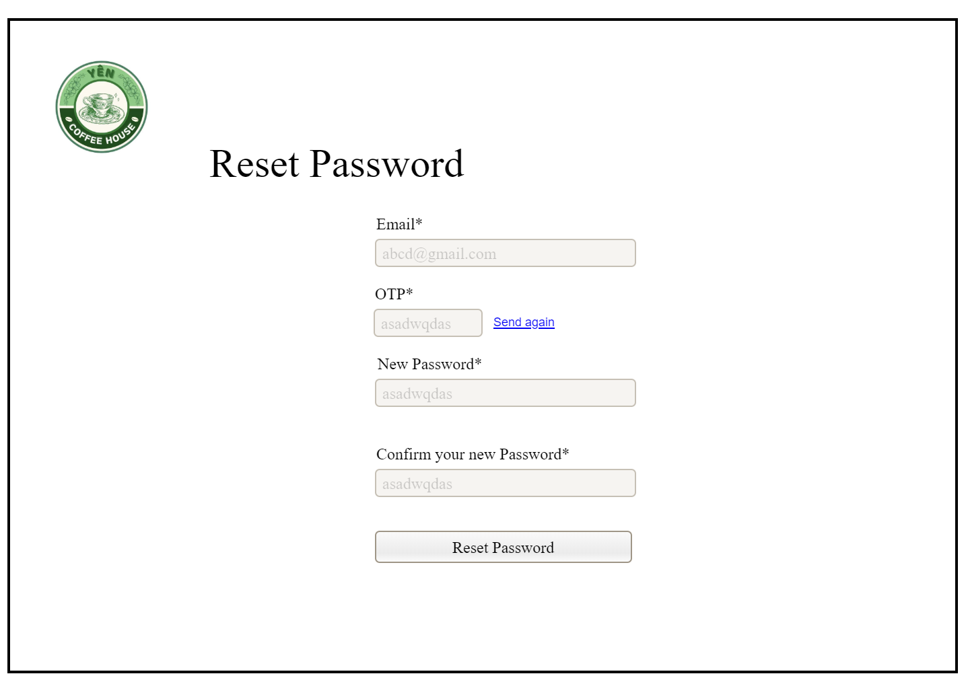**This screen allows the Customer to:**

* Reset their account password if forgotten or compromised.
* Enter their registered **Email** to receive an OTP.
* Verify identity using the **OTP (One-Time Password)** sent via email.
* Create a new password and confirm it before saving.

**On the screen, s/he can also:**

* Request a new OTP by clicking **Send again** if the first one expires or is lost.
* Confirm the password reset by clicking the **Reset Password button**.

**Field Description**

| **Field Name** | **Description** |
| --- | --- |
| (1) Logo | Displays Coffee Shop’s branding for consistency. |
| (2) Email | Input field for the user’s registered email address. |
| (3) OTP | Field to enter the One-Time Password sent to the registered email. |
| (4) Send Again | Link to request a new OTP in case the current one is invalid/expired. |
| (5) New Password | Input field for entering a new password. |
| (6) Confirm New Password | Input field to re-enter the new password to avoid mistakes. |
| (7) Reset Password Button | Submits the form to confirm and apply the new password. |

### 2.4 View My Orders

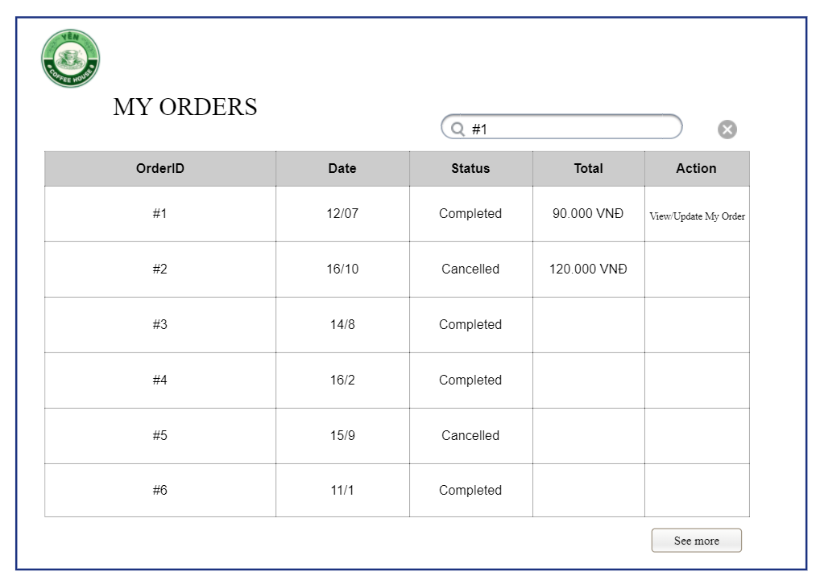

**This screen allows the user to:**

* View list of all their orders
* Check status of each order (Date, Total, Completed, Cancelled)
* View or update order details

**Field Description**

| **Field Name** | **Description** |
| --- | --- |
| Order ID | Enter a valid registered email address |
| Order Date | Date order was placed |
| Status | Current order status |
| Action | Options to view/update/cancel order |

### 2.5 View My Orders

#### 

**This screen allows the user to:**

* View order details (Order ID, date, type, status).
* See product details (name, size, customization, price).
* Apply or view a discount code.
* Update the quantity of items in the order.
* Save changes to the order.
* Navigate back to the order list.

**Field Description**

| **Field Name** | **Description** |
| --- | --- |
| Order ID | Unique identifier for the order |
| Order Date | Date order was placed |
| Order Status | Current order status |
| Order Type | Mode of order: Takeaway, Dine-in, or Delivery. |
| Discount Code | Promo/discount code applied to the order |
| Product Name | Name of the ordered drink/food (e.g., Black Coffee (M)). |
| Customization | Customer preferences (e.g., Less Sugar, Less Ice). |
| Price | Unit price of the product |
| Quantity Selector | Allows users to increase/decrease the item quantity (with + / – buttons). |
| Back Button | back to the previous screen (My orders). |
| Save Change Button | Saves updated changes (e.g., new quantity, discount). |

#### 

#### 

### 2.6 Manage User Profile

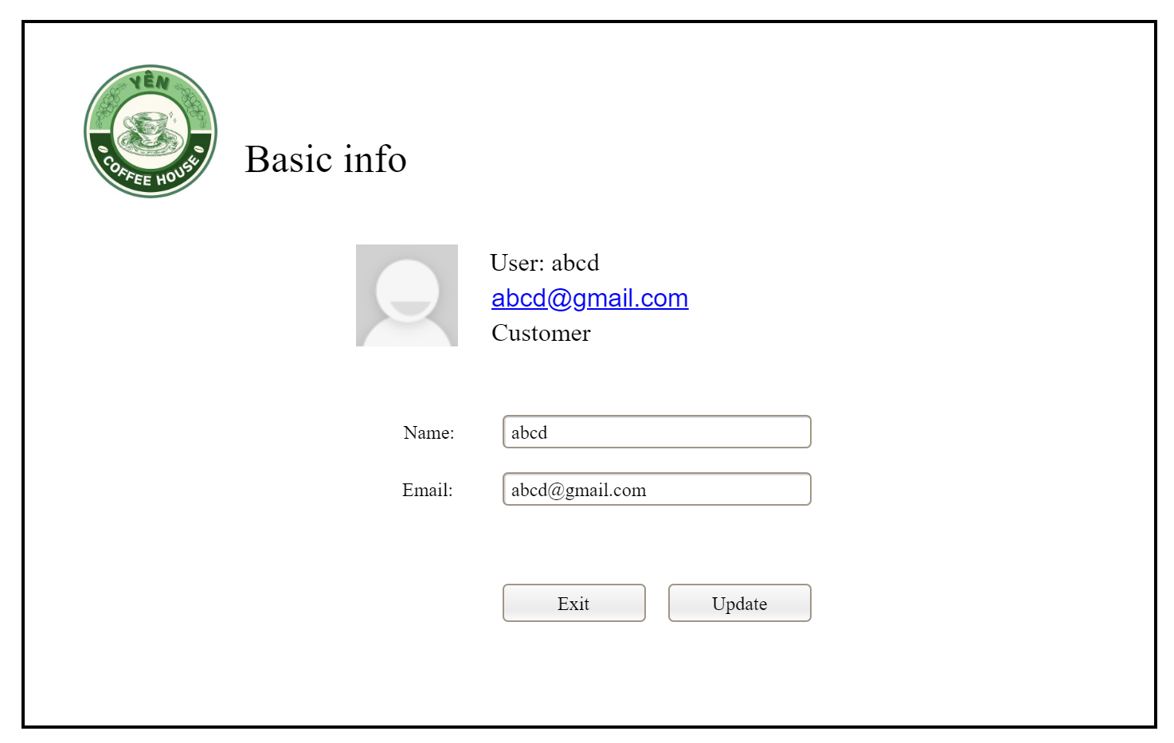

**This screen allows the Customer to:**

* View their basic account information including username, email address, and role (e.g., Customer).
* See a profile placeholder image representing the user.
* Edit and update their personal information (Name and Email) using input fields.
* Exit without making changes or save updates with the provided buttons.

**On the screen, s/he can also:**

* Click on their email link (displayed in blue) to directly interact with it (e.g., open default mail client).
* Use the Update button to save new information.
* Use the Exit button to cancel changes and return to the previous screen.

**Field Description**

| **Field Name** | **Description** |
| --- | --- |
| (1) Logo | Displays the Coffee Shop’s branding on the top-left corner. |
| (2) User Info | Shows username, email, and user role (Customer). Email is clickable. |
| (3) Profile Image | Placeholder avatar image for the user. |
| (4) Name Field | Input field allowing the user to edit their name. |
| (5) Email Field | Input field allowing the user to edit their email address. |
| (6) Exit Button | Cancels the update process and exits the screen. |
| (7) Update Button | Confirms and saves the user’s updated information. |

### 2.7 Password Change

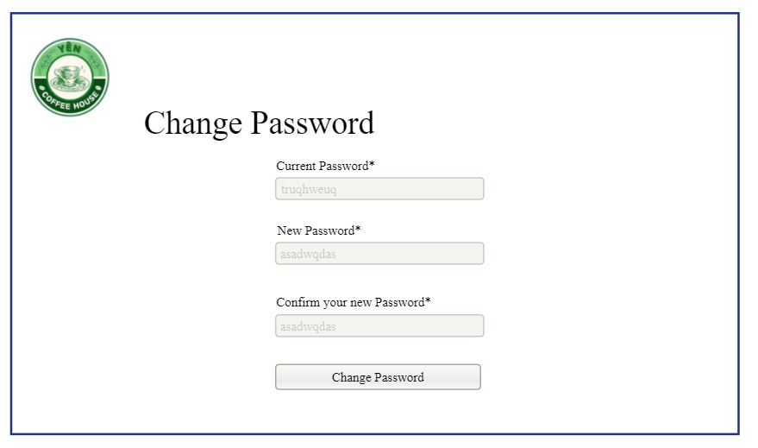

**This screen allows the Customer to:**

* Enter their current password to verify identity.
* Provide a new password and confirm it to ensure accuracy.
* Submit the password change using the Change Password button.

**On the screen, s/he can also:**

* Prevent mistakes by entering the new password twice (validation check).
* Cancel or navigate away without saving (implicit by browser navigation).
* Securely update login credentials for future authentication.

**This screen allows the user to:**

* Change account password

**Field Description**

| **Field Name** | **Description** |
| --- | --- |
| (1) Logo | Displays Coffee Shop’s branding on the top-left corner. |
| (2) Current Password | Input field where the user enters their existing password for verification. |
| (3) New Password | Input field where the user sets a new password. |
| (4) Confirm New Password | Input field where the user retypes the new password to confirm correctness. |
| (5) Change Password Btn | Button that saves the new password and updates the user’s account credentials. |

## 3. System Administration

### 3.1 HR

#### 3.1.1 View HR Dashboard

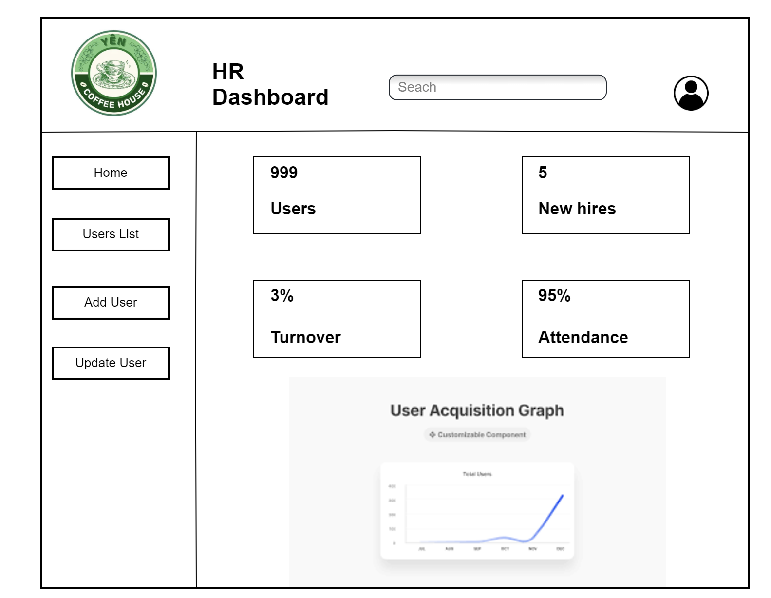

**This screen allows the HR staff to:**

* View a summary of key HR metrics such as **total users, new hires, turnover rate, and attendance percentage**.
* Search for users or HR-related records using the **Search bar**.
* Access navigation options through the left-side menu including **Home, User List, Add User, and Update User**.
* Analyze workforce trends via the **User Acquisition Graph**.

**On the screen, s/he can also:**

* Monitor the organization’s HR performance in real-time.
* Add or update employee/user records directly from the dashboard.
* Use the profile icon on the top-right to manage HR account settings.
* Generate insights for HR decision-making based on the displayed metrics and graph.

**Field Description**

| **Field Name** | **Description** |
| --- | --- |
| (1) Logo | Displays Coffee Shop’s branding on the top-left corner. |
| (2) HR Dashboard Title | Identifies the page as the HR Dashboard. |
| (3) Search Box | Input field for searching users or HR-related data. |
| (4) Profile Icon | Allows HR staff to access account profiles/settings. |
| (5) Side Menu | Provides navigation options: Home, Users List, Add User, Update User. |
| (6) Users | Shows the total number of users in the system (e.g., 999). |
| (7) New Hires | Displays the number of employees hired recently (e.g., 5). |
| (8) Turnover | Shows the turnover rate (e.g., 3%). |
| (9) Attendance | Displays the attendance rate (e.g., 95%). |
| (10) User Acquisition Graph | Visual graph showing user growth/acquisition over time. |

#### 3.1.2 View User List

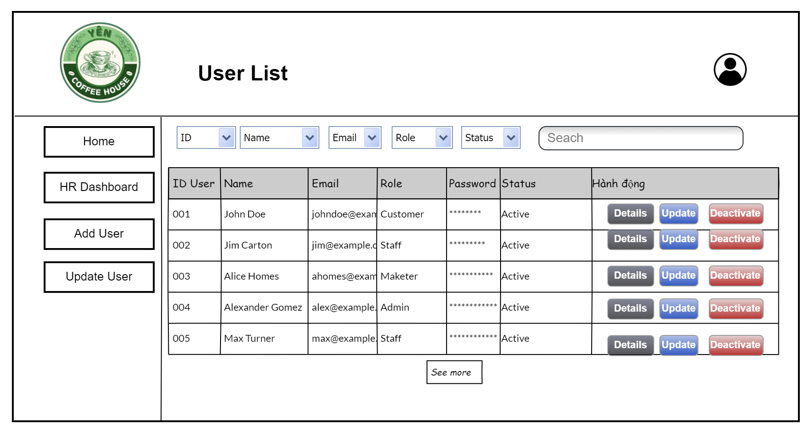

**This screen allows the HR/Admin user to:**

* View all registered users in a structured **User List Table**.
* Filter and search users by **ID, Name, Email, Role, or Status**.
* Manage users with quick action buttons (**Details, Update, Deactivate**).
* Navigate between modules using the **side menu**: Home, HR Dashboard, Add User, Update User.
* Securely logout or access their profile via the **Profile Icon**.

**On the screen, s/he can also:**

* Sort the list of users using the dropdown filters.
* Click **Details** to see full information about a selected user.
* Click **Update** to edit user details.
* Click **Deactivate** to disable a user account.
* Use the **See More** button to load additional user records if the list is long.

**Field Description**

| **Field Name** | **Description** |
| --- | --- |
| (1) Logo | Displays Coffee Shop’s branding on the top-left corner. |
| (2) Title | Page title: “User List.” |
| (3) Navigation Panel | Side menu: Home, HR Dashboard, Add User, Update User. |
| (4) Profile Icon | Opens HR/Admin profile or account options. |
| (5) Logout Button | Ends the current session. |
| (6) Filters & Search | Dropdowns + search bar to filter users by ID, Name, Email, Role, or Status. |
| (7) User List Table | Displays user information: ID User, Name, Email, Role, Password (masked), Status. |
| (8) User Actions | Per-row buttons: Details, Update, Deactivate. |
| (9) Status Column | Expands the table to load more users. |

#### 3.1.3 Add New User

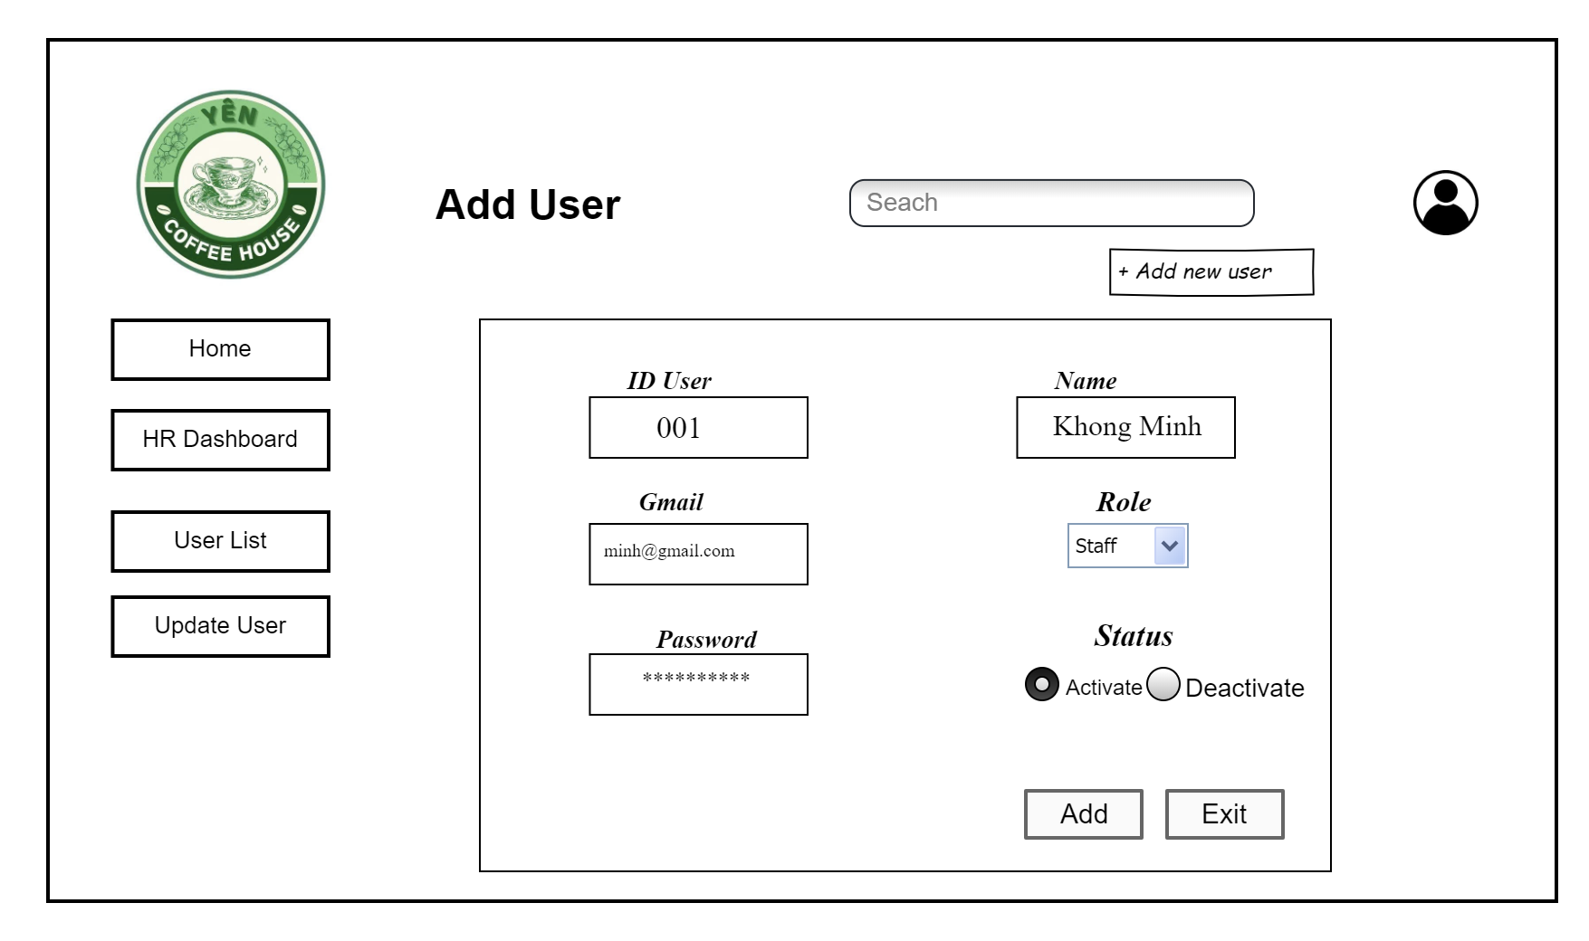

**This screen allows the Admin or HR Staff to:**

* View the company/store **Logo** on the top-left corner.
* Navigate through the sidebar with options: **Home, HR Dashboard, User List, Update User**.
* Use the **Search Box** on the top bar to find specific users or related content.
* Open the **User Profile Icon** on the top-right to manage their own account.

**On the screen, s/he can also:**

* Enter a new **User ID**, **Name**, **Email**, and **Password**.
* Select the **Role** (e.g., Customer, Staff, Admin, Marketer).
* Set the **Status** of the user account (Activate or Deactivate).
* Add the user by clicking the **Add** button.
* Exit the form using the **Exit** button.
* Use the **+ Add new user** quick action on top for convenience.

**Field Description**

| **Field Name** | **Description** |
| --- | --- |
| (1) Logo | Displays Coffee Shop’s branding. |
| (2) Sidebar | Navigation options: Home, HR Dashboard, User List, Update User. |
| (3) Search Box | Allows the admin to search for users or content quickly. |
| (4) User ID | Unique identifier for the new user (e.g., ST001). |
| (5) Name | Full name of the new user. |
| (6) Email | Email address used for login and notifications. |
| (7) Password | Initial password for the new user’s account. |
| (8) Role | Dropdown to assign a role (Staff, Customer, Admin, etc.). |
| (9) Status | Radio buttons to select account state: Activate or Deactivate. |
| (10) Add | Confirms and saves the new user to the system. |
| (11) Exit | Cancels the process and exits the Add User form. |

#### 3.1.4 Update User Detail

**This screen allows the Admin or HR Staff to:**

* View the company/store **Logo** on the top-left corner.
* Navigate through the sidebar with options: **Home, HR Dashboard, User List, Add User**.
* Use the **Search Box** on the top bar to quickly look up users.
* Access the **User Profile Icon** at the top-right corner for account settings.

**On the screen, s/he can also:**

* View and edit a user’s **ID, Name, Email, Password, Role, and Status**.
* Change the **Role** of a user by selecting from the dropdown (Customer, Staff, Admin, etc.).
* Modify the **Status** of a user (Activate or Deactivate).
* Save the updated information by clicking the **Save** button.
* Exit without saving changes by clicking the **Exit** button.

**Field Description**

| **Field Name** | **Description** |
| --- | --- |
| (1) Logo | Displays Coffee Shop’s branding. |
| (2) Sidebar | Navigation menu: Home, HR Dashboard, User List, Add User. |
| (3) Search Box | Allows admin to quickly search users or system data. |
| (4) User ID | Unique identifier for the user (not editable). |
| (5) Name | Displays the full name of the user (editable if needed). |
| (6) Email | User’s registered email (editable if needed). |
| (8) Role | Dropdown list to assign/update the user role. |
| (9) Status | Radio buttons to Activate or Deactivate the account. |
| (10) Save | Confirms changes and updates the user in the system. |
| (11) Exit | Cancels the update process and closes the form. |

### 3.2 Marketing

#### 3.2.1 Marketing Dashboard

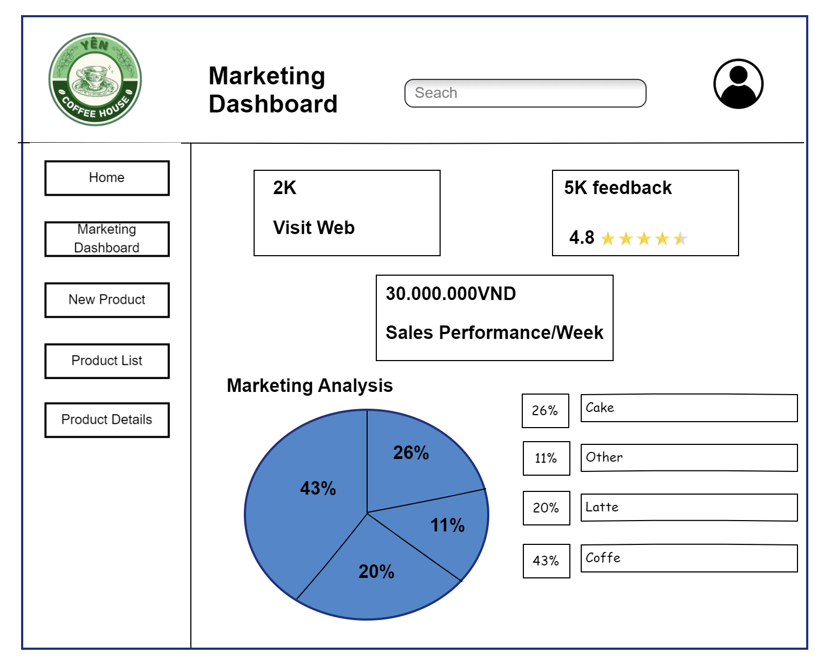

**This screen allows the Marketer to:**

* View the Coffee House logo on the top-left corner.
* Navigate through the side menu with options: Home, Product List, Add New Product, Update Product.
* Use the Search bar at the top for quick access to products or information.
* Check Visit Web statistics (2K) to track website traffic.
* Monitor Customer Feedback (5K responses) and the average rating (4.8 stars).
* View Sales Performance per Week with total revenue displayed (30,000,000 VND).
* Analyze the Marketing Analysis chart, showing product distribution by percentage:  
  + 43% Coffee
  + 26% Cake
  + 20% Latte
  + 11% Other

**On the screen, s/he can also:**

* Click Product List to see all available products.
* Use Add New Product to input a new product into the system.
* Select Update Product to modify existing product details.
* Read insights from the Marketing Analysis pie chart to evaluate sales distribution.

**Field Description**

| **Field Name** | **Description** |
| --- | --- |
| (1) Logo | Displays Coffee Shop’s branding. |
| (2) Side Menu | Navigation options: Home, Product List, Add New Product, Update Product. |
| (3) Search Bar | Allows searching for products or data within the dashboard. |
| (4) Visit Web | Displays the number of website visits (2K). |
| (5) Feedback & Rating | Shows the number of customer feedback entries (5K) and average rating (4.8 stars). |
| (6) Sales Performance | Displays weekly sales revenue (30,000,000 VND). |

#### 3.2.2 Add new product

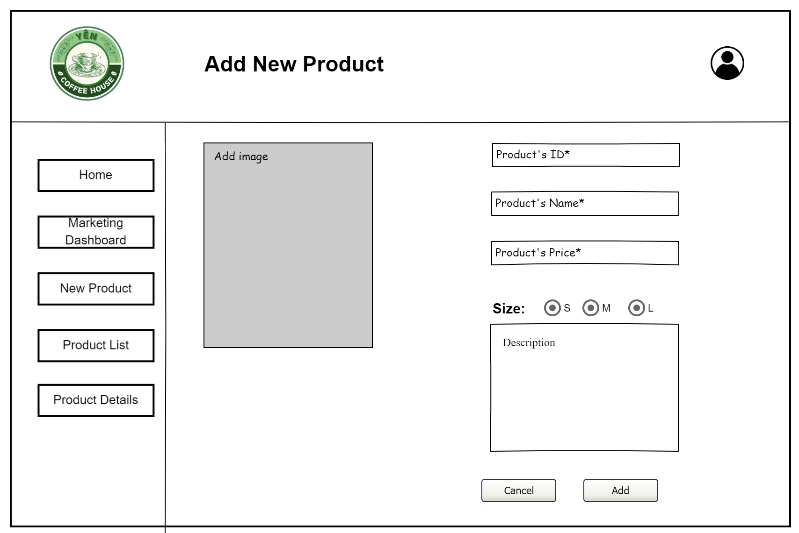

**This screen allows the Marketer to:**

* View the **Coffee House logo** for branding.
* Navigate using the side menu with options: **Home, Marketing Dashboard, Product List, Update Product**.
* Upload a **Product Image** to visually represent the new product.
* Input the **Product’s ID, Name, and Price**.
* Select the **Product Size** (S, M, L).
* Add a **Product Description** to provide details about the item.
* Save the new product information by clicking **Add** or cancel the process with **Cancel**.

**On the screen, s/he can also:**

* Use the side navigation to quickly switch to other marketing functions (Dashboard, Product List, Update Product).
* Upload and preview an image before adding the product.
* Assign different prices and descriptions according to product sizes.
* Cancel the operation without saving data.

| **Field Name** | **Description** |
| --- | --- |
| (1) Logo | Displays Coffee Shop’s branding. |
| (2) Side Menu | Navigation options: Home, Marketing Dashboard, Product List, Update Product. |
| (3) Product Image | Allows uploading an image for the product. |
| (4) Product’s ID | Unique identifier for the product. |
| (5) Product’s Name | Text field for entering the product name. |
| (6) Product’s Price | Text field for entering the product price. |
| (7) Size Options | Radio buttons to select product size: Small (S), Medium (M), Large (L). |
| (8) Description | Text area for providing details about the product. |
| (9) Cancel Button | Discards the action and returns to the previous screen. |
| (10) Add Button | Confirms and saves the new product into the system. |

#### 

#### 3.2.3 Products list

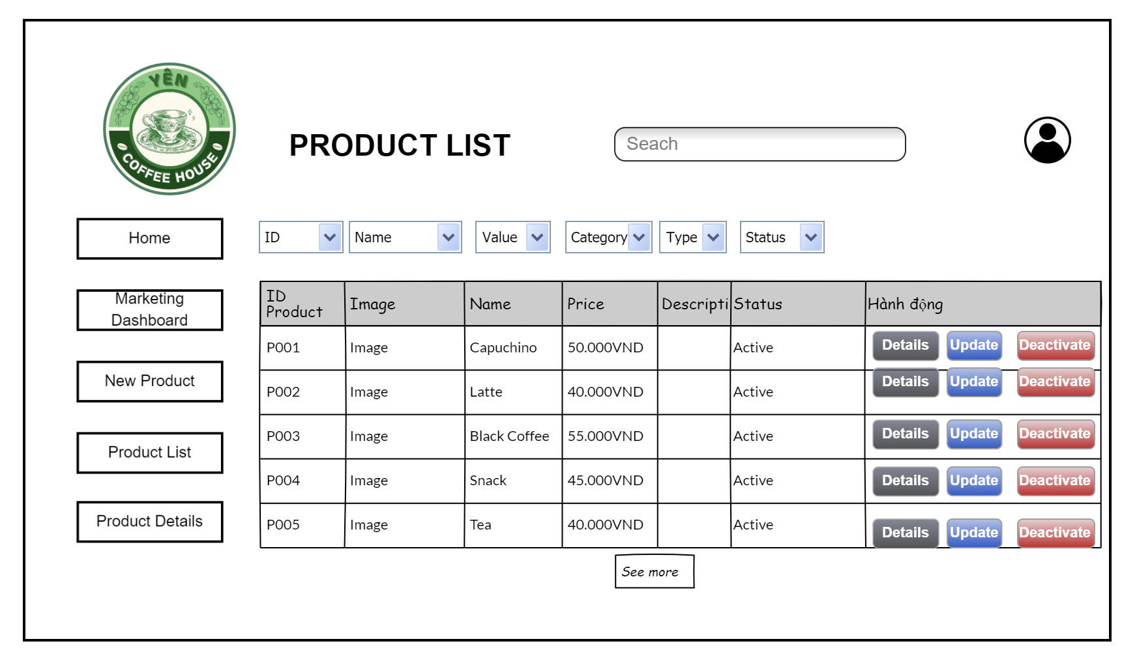

**This screen allows the Marketer/Admin to:**

* View the **company logo** on the top-left corner for branding identity.
* Use the **side navigation menu** (Home, Marketing Dashboard, New Product, Product List, Product Details).
* Search and filter products by **ID, Name, Value, Category, Type, Status**.
* See a table of product details including ID, Image, Name, Price, Description, Status.
* Perform actions for each product using buttons: **Details**, **Update**, **Deactivate**.
* View more products using the **See more** button at the bottom.

**On the screen, s/he can also:**

* Navigate between product-related pages through the sidebar.
* Click the **profile icon** on the top-right for account management.
* Sort or filter product data dynamically via dropdown filters.

**Field Description**

| **Field Name** | **Description** |
| --- | --- |
| (1) Coffee Shop Logo | Coffee House branding, displayed on top-left. |
| (2) Navigation | Sidebar menu with quick links: Home, Marketing Dashboard, New Product, Product List, Product Details. |
| (3) Search bar | Allows searching products by keyword. |
| (4) Filters | Dropdown menus to filter/sort products by ID, Name, Value, Category, Type, Status. |
| (5) ID Product | Unique identifier for each product. |
| (6) Image | Thumbnail image representing the product. |
| (7) Name | Name of the product (e.g., Capuchino, Latte). |
| (8) Price | Product price shown in local currency (VND). |
| (9) Description | Buttons for managing the product: Details (view info), Update (edit), Deactivate (disable). |
| (12) See more | Loads additional products if the list is long. |
| (13) Profile Icon | Access to user profile or logout options. |

#### 

#### 3.2.4 Product Details

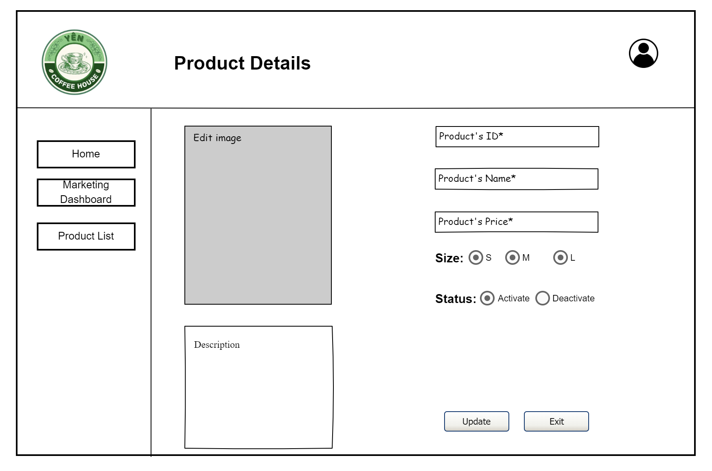

**This screen allows the Marketer/Admin to:**

* View the company/store **Logo** at the top-left corner for brand recognition.
* Navigate between modules using the left-side menu (Home, Marketing Dashboard, Product List).
* View and edit details of an existing product.
* Update product information such as **Product ID, Name, Price, Size, Description**, and **Status**.
* Manage the product’s availability (Activate or Deactivate).
* Edit the product image if needed.

**On the screen, s/he can also:**

* Use the **Update** button to save the edited product information.
* Use the **Exit** button to leave the page without saving.
* Choose the appropriate product size (S, M, L).
* Control product visibility by switching between **Activate** and **Deactivate**.

| **Field Name** | **Description** |
| --- | --- |
| (1) Coffee Shop Logo | Input field that allows staff/admin to search for products by name. |
| (2) Menu Panel | Provides navigation links: Home, Marketing Dashboard, Product List. |
| (3) Product’s ID | Unique identifier for the product. |
| (4) Product’s Name | Name of the product (e.g., Latte, Cappuccino). |
| (5) Product’s Price | Selling price of the product. |
| (6) Size | Available product sizes: S, M, or L. |
| (7) Status | Available product sizes: S, M, or L. |
| (8) Description | Field for product information and details. |
| (9) Edit Image | Allows uploading or updating the product’s image. |
| (10) Update Button | Saves changes made to the product. |
| (11) Exit Button | Exits the product details page without saving changes. |

#### 

#### 3.2.5 Promotion List

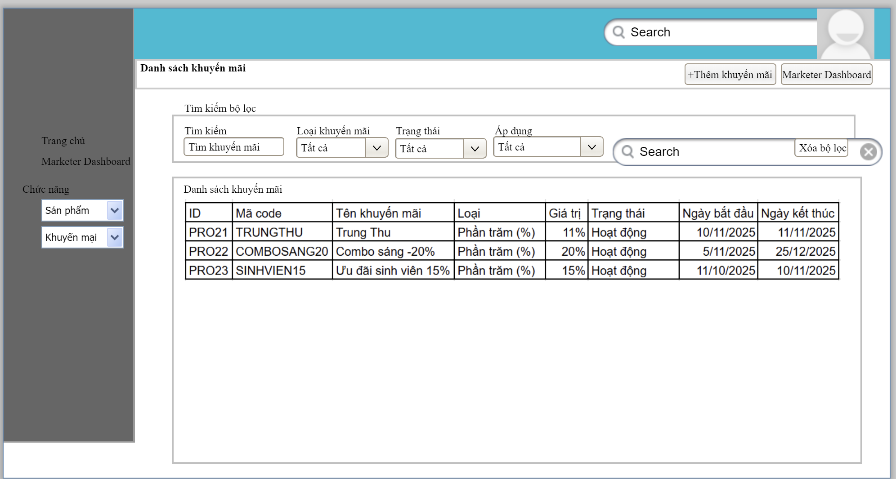

### **This screen allows the Marketer/Admin to:**

* View the company/store Logo and global Search bar at the top for quick navigation and brand recognition.
* Navigate between modules using the left-side menu (Home, Marketer Dashboard, Product module, Promotion module).
* Access the Marketer Dashboard using the shortcut button on the top-right area.
* Create a new promotion using the “+ Add Promotion” button.
* Search and filter promotions by keyword, promotion type, status, and applicable target.
* View the promotion list table, including promotion code, name, type, value, status, start date, and end date.
* Quickly clear all filters using the Clear Filters button to reset the list.

**On the screen, s/he can also:**

* Use the Search button to apply the selected filter conditions and refresh the promotion list.
* Scroll the promotion list table to review all available promotions.
* Identify which promotions are Active or Inactive/Expired using the “Status” column.
* Verify promotion periods by checking the Start Date and End Date columns.

| **Field Name** | **Description** |
| --- | --- |
| (1) Coffee Shop Logo | Input field that allows staff/admin to search for products by name. |
| (2) Global Search Bar | Input field at the top-right that allows staff/admin to quickly search across the system (optional global search). |
| (3) User Profile Area | Shows the current user/avatar and may provide access to account options. |
| (4) Left-Side Menu Panel | Provides navigation links such as Home, Marketer Dashboard, and function groups (Products, Promotions). |
| (5) Function Selector – Products | Dropdown item in the left menu that switches the view to product-related screens. |
| (6) Function Selector – Promotions | Dropdown item in the left menu that opens promotion-related screens, including this Promotion List. |
| (7) Screen Title – “Promotion List” | Header label indicating that the current screen shows the list of promotions. |
| (8) Add Promotion Button | “+ Add Promotion” button that opens the screen for creating a new promotion. |
| (9) Marketer Dashboard Button | Shortcut button that returns the user to the Marketer Dashboard screen. |
| (10) Filter – Search Promotion | Text input used to search promotions by name or code. |
| (11) Filter – Promotion Type | Dropdown list used to filter promotions by type (e.g., Percentage, Fixed Amount, Combo, etc.). |
| (12) Filter – Status | Dropdown list used to filter promotions by status (e.g., All, Active, Inactive, Expired). |
| (13) Filter – Apply To | Dropdown list used to filter promotions by their application scope (e.g., All products, Specific products, Combo, etc.). |
| (14) Filter Search Button | Button that applies the selected filters and reloads the promotion list. |
| (15) Clear Filters Button | “Clear Filters” button that resets all filter fields and restores the default promotion list. |
| (16) Promotion List Table | Main data grid that displays all matching promotions after filters are applied. |
| (17) Column – ID | Internal identifier or row number for each promotion record. |
| (18) Column – Code | Promotion code used by customers at checkout (e.g., TRUNGTHU, COMBOSANG20). |
| (19) Column – Promotion Name | Descriptive name of the promotion (e.g., “Mid-Autumn Festival”, “Student Discount 15%”). |
| (20) Column – Type | Indicates the promotion type such as Percentage (%) or Fixed Amount. |
| (21) Column – Value | Shows the promotion value (e.g., 11%, 20%). |
| (22) Column – Status | Displays the current status of the promotion (e.g., Active, Inactive, Expired). |
| (23) Column – Start Date | Date when the promotion becomes effective. |
| (24) Column – End Date | Date when the promotion expires and is no longer applied. |

#### 3.2.5 Promotion New

#### 

### **This screen allows the Marketer/Admin to:**

* View the company/store Logo and global Search bar at the top for quick navigation and brand recognition.
* Navigate between modules using the left-side menu (Home, Marketer Dashboard, Products, Promotions).
* Access the promotion section using the “Promotions” function group and return to the Promotion List screen with the “Back to List” button.
* Enter all required information to create a new promotion, including name, code, type, value, description, scope, and active period.
* Choose the application scope of the promotion (all products or specific products) and optionally set a minimum order amount.
* Set the status of the promotion (Active, Paused, or Upcoming) before saving.
* Add internal notes for staff, which are not visible to customers.

**On the screen, s/he can also:**

* Use the “Reset” button to clear all input fields and start over.
* Use the “Save Promotion” button to validate input and create the new promotion in the system.
* Use the Start Date and End Date fields to define the promotion’s valid period.

| **Field Name** | **Description** |
| --- | --- |
| (1) Coffee Shop Logo | Displays the coffee shop’s logo at the top-left corner for brand recognition. |
| (2) Global Search Bar | Input field at the top-right that allows staff/admin to quickly search across the system (optional global search). |
| (3) Left-Side Menu Panel | Provides navigation links such as Home, Marketer Dashboard, Products, and Promotions. |
| (4) Function Selector – Products | Dropdown item used to switch to product-related screens. |
| (5) Function Selector – Promotions | Dropdown item used to open promotion-related screens, including this Create New Promotion form. |
| (6) Screen Title – “Create New Promotion” | Indicates that the current screen is used to create a new promotion and shows a short instruction text. |
| (7) Section Header – “Promotion Information” | Visual panel title grouping all fields related to promotion details. |
| (8) Promotion ID (Auto-generated) | Read-only field showing the system-generated ID for the promotion. |
| (9) Promotion Name | Text field where the marketer enters the name of the promotion (e.g., “Welcome Offer 10%”). |
| (10) Promotion Code | Text field for the promotion code that customers will enter at checkout (e.g., WELCOME10). |
| (11) Promotion Type | Dropdown list for selecting the promotion type (e.g., Percentage discount, Fixed amount, Free item…). |
| (12) Promotion Value | Numeric field specifying the discount value, such as percentage or fixed amount, based on the selected type. |
| (13) Promotion Description | Multiline text area used to describe the promotion’s details, conditions, and message shown to customers. |
| (14) Application Scope – All Products | Radio button to apply the promotion to all products in the catalog. |
| (15) Application Scope – Specific Products | Radio button to apply the promotion only to selected products (selection handled in another step or dialog). |
| (16) Minimum Order Amount | Input field for the minimum order value required to use this promotion (or “Not required”). |
| (17) Status – Active | Radio button to mark the promotion as currently active when the date range is valid. |
| (18) Status – Paused | Radio button to temporarily disable the promotion without deleting it. |
| (19) Status – Upcoming | Radio button to indicate that the promotion will start in the future (based on Start Date). |
| (20) Start Date | Date picker for the promotion’s start date. The promotion becomes valid from this date. |
| (21) End Date | Date picker for the promotion’s end date. The promotion stops being applied after this date. |
| (22) Internal Notes | Multiline text area for internal comments or configuration notes visible only to staff. |
| (23) Reset Button | “Reset” button that clears all entered data in the form and returns fields to their default state. |
| (24) Save Promotion Button | “Save Promotion” button that validates the form and creates the new promotion record in the system. |
| (25) Back to List Button | “Back to List” button that navigates back to the Promotion List screen without saving changes. |

#### 

#### 3.2.6 Promotion List

### **This screen allows the Marketer/Admin to:**

* View the company/store **Logo** and global **Search** bar at the top for quick navigation and brand recognition.
* Navigate between modules using the **left-side menu** (Home, Marketer Dashboard, Products, Promotions).
* View full **details of an existing promotion**, including ID, name, code, type, value, scope, status, validity period, description, and internal notes.
* Review the **application scope** (all products or specific products) and any **minimum order requirement** associated with the promotion.
* Check the **current status** of the promotion (Active, Paused, Upcoming) and its **start/end dates** to understand when it is valid.
* Go back to the **Promotion List** screen using the “Back to List” button.
* Open the **Edit Promotion** screen using the “Edit Promotion” button in order to modify the promotion.

On the screen, s/he can also:

* Use the **Reset** button to refresh the displayed data (reload original values from the system) if any temporary changes are made in the form.

| **Field Name** | **Description** |
| --- | --- |
| (1) Coffee Shop Logo | Displays the coffee shop’s logo at the top-left corner for brand recognition. |
| (2) Global Search Bar | Input field at the top-right that allows staff/admin to quickly search across the system (optional global search). |
| (3) Left-Side Menu Panel | Provides navigation links such as Home, Marketer Dashboard, Products, and Promotions. |
| (4) Function Selector – Products | Dropdown item used to switch to product-related screens. |
| (5) Function Selector – Promotions | Dropdown item used to open promotion-related screens (Promotion List, Promotion Details, etc.). |
| (6) Screen Title – “Create New Promotion” | Title that indicates the user is viewing detailed information of a promotion and shows a short helper text. |
| (7) Section Header – “Promotion Information” | Title that indicates the user is viewing detailed information of a promotion and shows a short helper text. |
| (8) Promotion ID (Auto-generated) | Read-only field showing the unique system ID of the promotion (e.g., #PR021). |
| (9) Promotion Name | Text field where the marketer enters the name of the promotion (e.g., “Welcome Offer 10%”). |
| (10) Promotion Code | Text field for the promotion code that customers will enter at checkout (e.g., WELCOME10). |
| (11) Promotion Type | Dropdown list for selecting the promotion type (e.g., Percentage discount, Fixed amount, Free item…). |
| (12) Promotion Value | Numeric field specifying the discount value, such as percentage or fixed amount, based on the selected type. |
| (13) Promotion Description | Multiline text area used to describe the promotion’s details, conditions, and message shown to customers. |
| (14) Application Scope – All Products | Radio button to apply the promotion to all products in the catalog. |
| (15) Application Scope – Specific Products | Radio button to apply the promotion only to selected products (selection handled in another step or dialog). |
| (16) Minimum Order Amount | Input field for the minimum order value required to use this promotion (or “Not required”). |
| (17) Status – Active | Radio button to mark the promotion as currently active when the date range is valid. |
| (18) Status – Paused | Radio button to temporarily disable the promotion without deleting it. |
| (19) Status – Upcoming | Radio button to indicate that the promotion will start in the future (based on Start Date). |
| (20) Start Date | Date picker for the promotion’s start date. The promotion becomes valid from this date. |
| (21) End Date | Date picker for the promotion’s end date. The promotion stops being applied after this date. |
| (22) Internal Notes | Multiline text area for internal comments or configuration notes visible only to staff. |
| (23) Reset Button | “Reset” button that clears all entered data in the form and returns fields to their default state. |
| (24) Save Promotion Button | “Save Promotion” button that validates the form and creates the new promotion record in the system. |
| (25) Back to List Button | “Back to List” button that navigates back to the Promotion List screen without saving changes. |

#### 

### 3.3 Cashier

#### 3.3.1 Cashier View Finance Dashboard

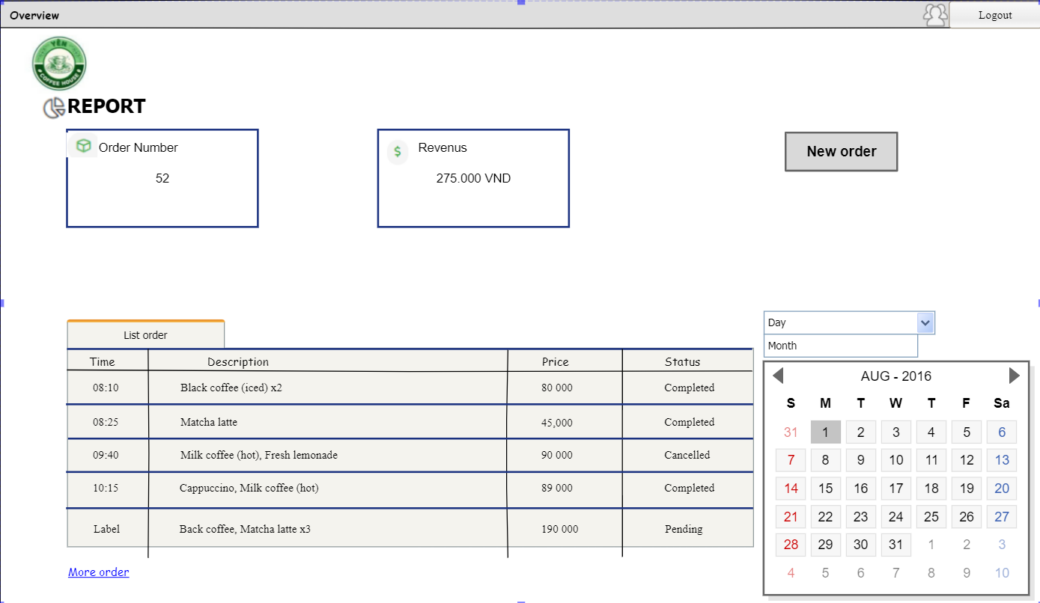

**This screen allows the cashier to:**

* View a quick summary of store performance (number of orders, total revenue) by day or month.
* Track a list of recent orders by time, description, price, and status (Completed or In Progress).
* Filter and view reports by day or month using the date picker and calendar.

**On the screen**

* Create new orders directly from the dashboard.
* Access account functions and log out of the system.
* Access the detailed order list

**Field Description**

| **Field Name** | **Description** |
| --- | --- |
| (1) User Profile Icon | Displays the account information of the logged in cashier |
| (2) Logout Button | Logs the user out of the system. |
| (3) Order Number | Order Number Displays the total number of orders within the selected date range |
| (4) Revenue | Displays the total revenue |
| (5) New Order Button | Creates a new order and redirects to the create new order screen. |
| (6) Order List Table | A table of recent orders with the following columns: Time, Description, price, status |
| (7) View More Orders Link | Redirects to the full order list screen. |
| (8)Date Filter | Drop-down menus to select a day/month view. |

#### 3.3.2 Create Order Invoice

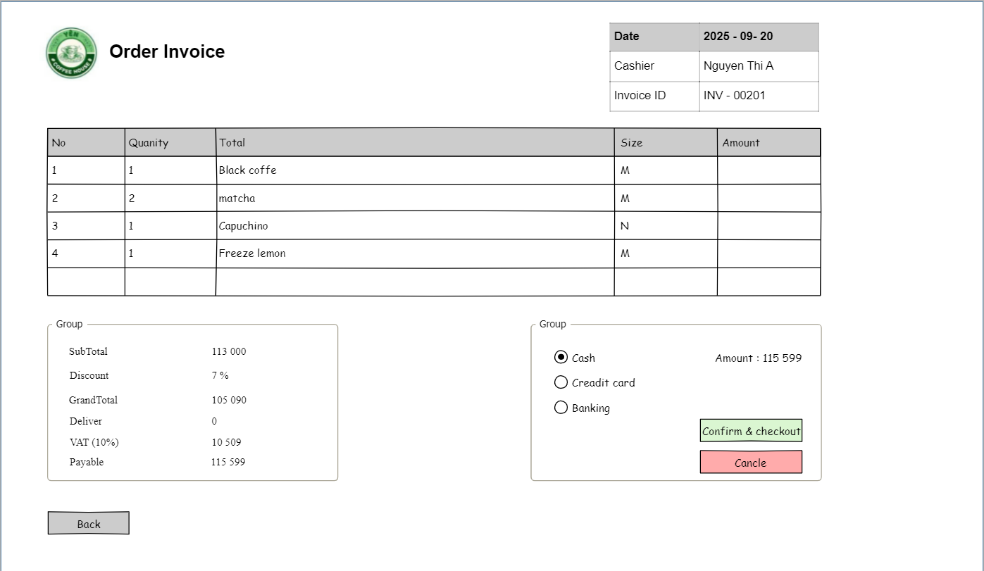

**Displays a list of all orders created in the system, allowing cashier to:**

* Quickly view order information.
* Filter and search orders by time or keyword.
* Track payment methods and notes.

**Field Description**

| **Field Name** | **Description** |
| --- | --- |
| (1) Dashboard | to return to the Dashboard module. |
| (2) Search Bar input | field to search for orders by keyword (e.g. order ID, description). |
| (3) Orders List: | The main panel displays all orders with details. |
| (4) Time column | displays the time the order was created. |
| (5) Number of product column | displays the number of products/items in the order. |
| (6) Price column | displays the total price of the order. |
| (7) Notes column | for any additional notes attached to the order. |
| (8)Payment Method column | displays the payment method (e.g. Cash, Card, E-Wallet). |

#### 

#### 3.3.3 Create New Order

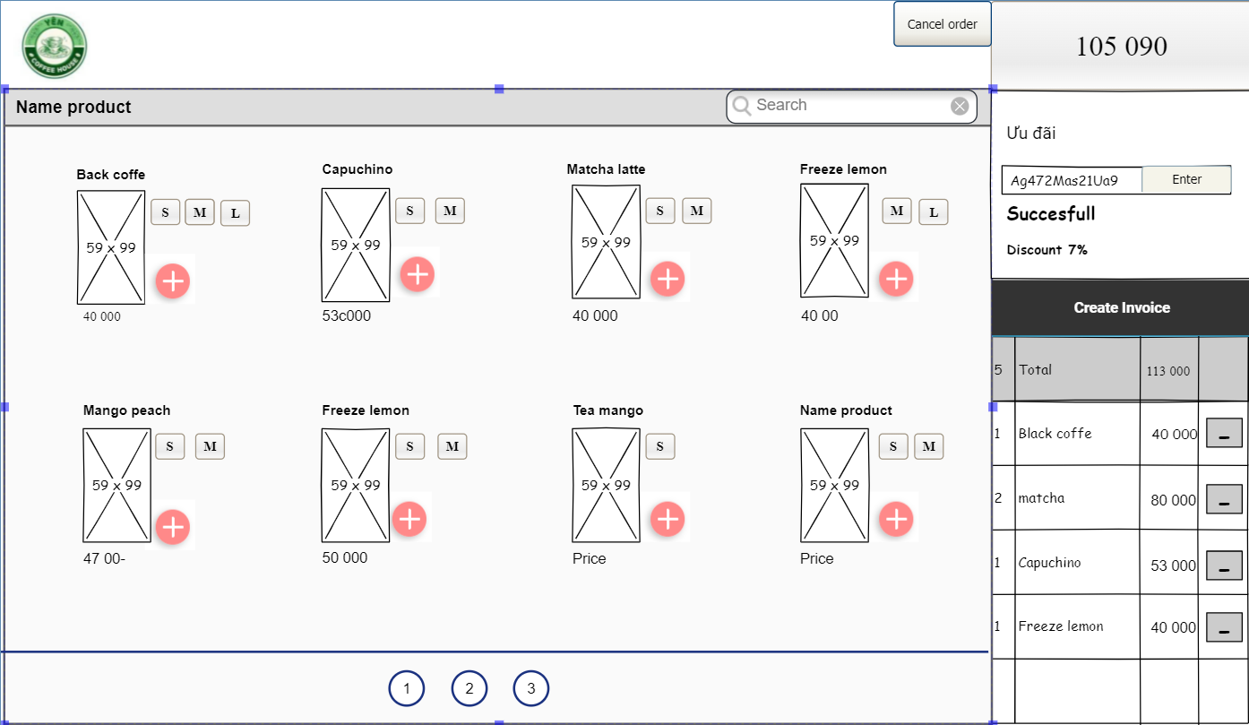

**This screen allows the cashier to:**

● View the current menu list with details such as Item, price and Status.

● Search for specific drinks in the menu using the search bar to add to the customer's order.

● View the current order in real time with information about the total number of products, number of products per type, total price per type.

● Navigate between modules using the sidebar (Dashboard, Order List).

**On the screen, the staff can also:**

● Cancel the entire order

● Click the Dashboard button to return to the dashboard while keeping the order information

● Enter a discount and see the final price

● View and invoice that order

**Field Description**

| **Field Name** | **Description** |
| --- | --- |
| (1) Dashboard | Dashboard Button Navigates to the Dashboard module. |
| (2) Cancel Order Button | Cancel Order Button Cancels the current order and deletes the selected items. |
| (3) Product Menu | Displays a list of available products with images, names, and prices. |
| (4) Add (+) Button | Allows staff to add products to an order. |
| (5) Search Bar | Input field to search for products by name. |
| (6) Amount Payable | Displays the total amount due for the current order. |
| (7) Loyalty Points | Input Field to apply reward points to the customer. |
| (8)Discount Input Field | to apply a discount or promotion code.. |
| (9) Order Checkout | lists the items added to the order with name, price, and quantity. |
| (10) (-) button | Allows the employee to reduce or remove products from the order. |
| (11) Payment | Confirm payment request and issue invoice |

#### 

#### 

### 3.4 Admin

#### 3.4.1 Admin Dashboard

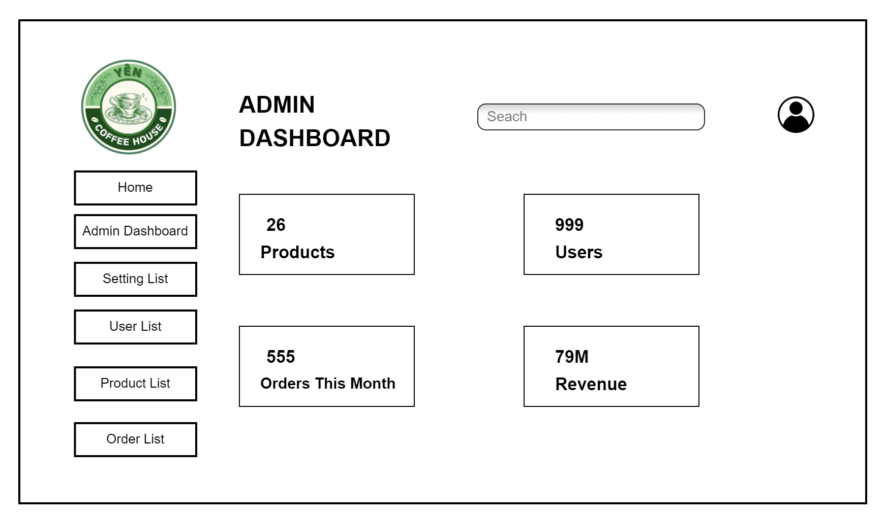

**This screen allows the Admin to:**

* See the **company logo** on the top-left for branding.
* Use the **sidebar navigation** (Home, Admin Dashboard, Setting List, User List, Product List, Order List).
* Perform searches using the **search bar** at the top.
* Access account settings or logout using the **profile icon** on the top-right.
* Monitor **overall system performance metrics** such as:  
  + **Products (26)**
  + **Users (999)**
  + **Orders This Month (555)**
  + **Revenue (79M)**

**On the screen, s/he can also:**

* Quickly **navigate to User List, Product List, or Order List** to manage each section.
* Monitor **business KPIs** in real time to ensure smooth operations.
* Use the **Setting List** option to configure system-wide preferences.
* Identify growth patterns (e.g., number of users vs. orders vs. revenue).

**Field Description**

| **Field Name** | **Description** |
| --- | --- |
| (1) Logo | Coffee House logo displayed for brand identity. |
| (2) Sidebar Menu | Links to Home, Admin Dashboard, Setting List, User List, Product List, Order List. |
| (3) Search Bar | Allows searching across products, users, or orders. |
| (4) Profile Icon | Provides access to admin profile settings or logout. |
| (5) Products | Total number of products currently active (e.g., 26). |
| (6) Users | Total registered users in the system (e.g., 999). |
| (7) Orders This Month | Number of orders processed in the current month (e.g., 555). |
| (8) Revenue | Total revenue generated (e.g., 79M). |

#### 

#### 3.4.2 Setting List

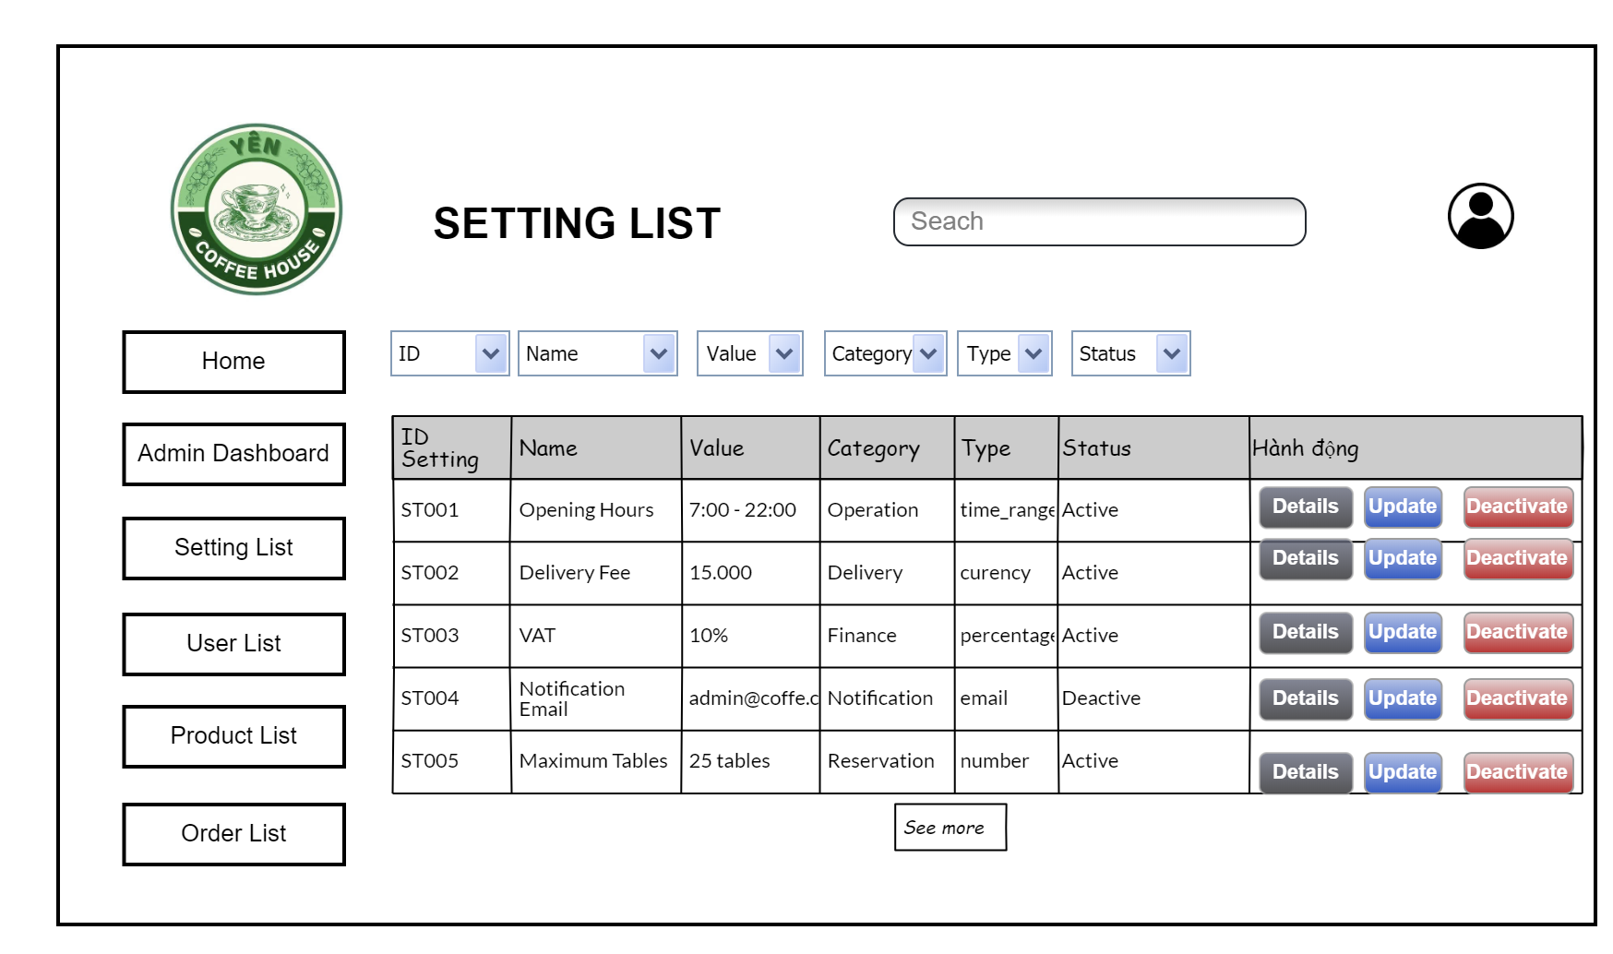

**This screen allows the Admin to:**

* View, search, and manage **system settings**.
* Navigate easily using the **sidebar** (Home, Admin Dashboard, Setting List, User List, Product List, Order List).
* Use the **search bar** and filter dropdowns (**ID, Name, Value, Category, Type, Status**) to quickly find settings.
* Perform actions for each setting item:  
  + **Details** → View setting details.
  + **Update** → Edit the setting.
  + **Deactivate** → Disable the setting if no longer applicable.

**On the screen, s/he can also:**

* Manage operational settings like **Opening Hours**, **Delivery Fee**, **VAT**, **Notification Email**, or **Maximum Tables**.
* Keep control of system-wide configurations across multiple categories:  
  + **Operation** (e.g., Opening Hours)
  + **Delivery** (e.g., Delivery Fee)
  + **Finance** (e.g., VAT)
  + **Notification** (e.g., system email)
  + **Reservation** (e.g., Maximum Tables).
* Easily see which settings are **Active** or **Deactivated**.
* Expand the list using the **“See more”** button.

**Field Description**

| **Field Name** | **Description** |
| --- | --- |
| (1) Logo | Displays company branding, located at the top-left. |
| (2) Sidebar Menu | Navigation buttons: Home, Admin Dashboard, Setting List. |
| (3) Search Bar | Input field to search for settings by keyword. |
| (4) Filters | Dropdowns to filter by ID, Name, Value, Category, Type, Status. |
| (5) ID Setting | Unique identifier for each setting (e.g., ST001, ST002). |
| (6) Name | The descriptive name of the setting (e.g., Opening hours, VAT). |
| (7) Value | The assigned value of the setting (e.g., 7:00–22:00, 10%). |
| (8) Category | The functional group of the setting (e.g., Operation, Delivery, Finance). |
| (9) Type | The data type of the setting (e.g., time_range, currency, percentage, email, number). |
| (10) Status | Current status of the setting (Active or Paused). |
| (11) Action | Available actions: Details, Update, Pause/Active. |
| (12) See more | Loads additional records if the list is long. |
| (13) Profile Icon | Provides access to administrator account options/settings. |

#### 

#### 3.4.3 Setting List Details

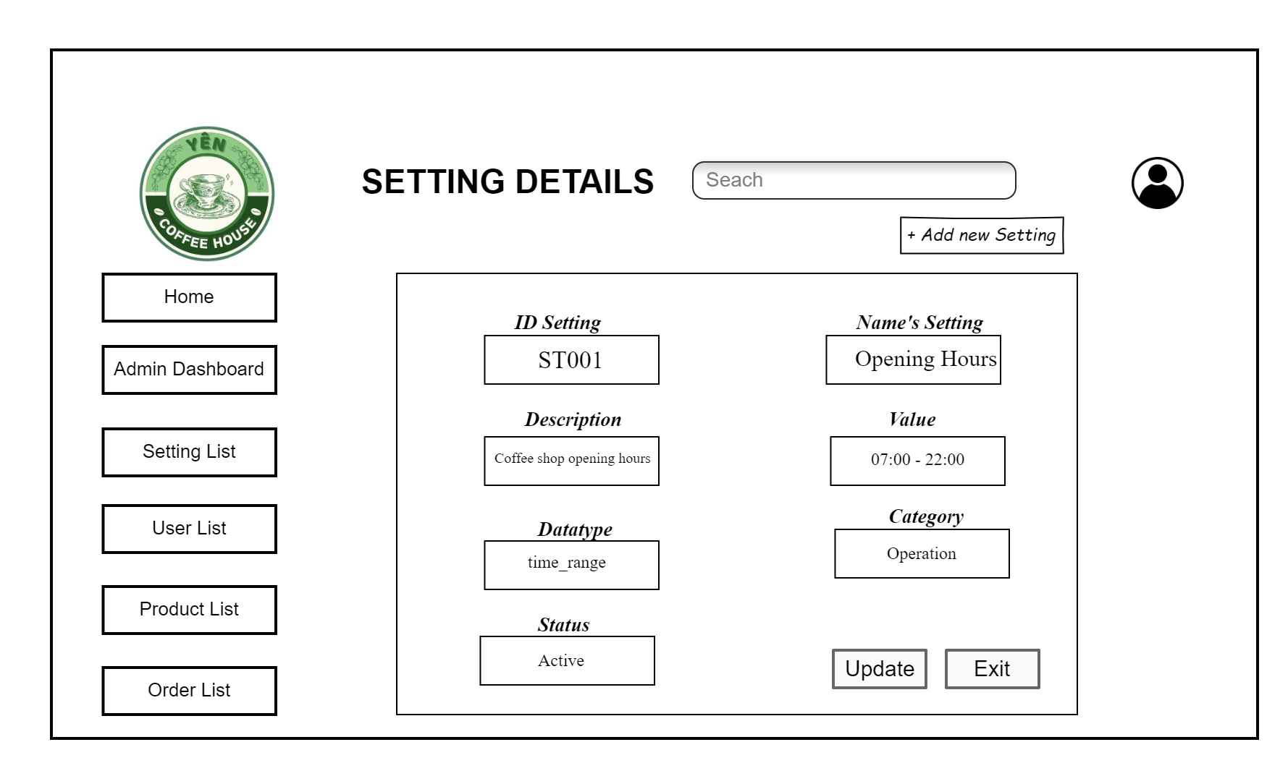

**This screen allows the Admin to:**

* View and update the details of a specific system setting.
* Navigate easily using the sidebar (Home, Admin Dashboard, Setting List, User List, Product List, Order List).
* Use the **search bar** to quickly locate a setting.
* Review and manage attributes like ID, Name, Value, Datatype, Category, and Status.

**On the screen, s/he can also:**

* Edit information for an existing setting (e.g., Opening Hours, Delivery Fee, VAT, Notification Email, Maximum Tables).
* Update the value of the setting (e.g., change from *7:00–22:00* to *6:00–23:00*).
* Switch the setting **Active / Deactive** depending on business needs.
* Use the shortcut **“+ Add new Setting”** to quickly add another configuration.
* Exit back to the **Setting List**.

**Field Description**

| **Field Name** | **Description** |
| --- | --- |
| (1) Logo | Displays company branding, located at the top-left. |
| (2) Sidebar Menu | Navigation buttons: Home, Admin Dashboard, Setting List. |
| (3) Screen Title | “Admin Dashboard” – identifies the page as the admin overview. |
| (4) Search Bar | Input field to search for data within the system. |
| (5) Add new Setting | Button to create a new system setting. |
| (6) ID Setting | Unique identifier for the setting (e.g., ST001). |
| (7) Name Setting | The descriptive name of the setting (e.g., Opening hours). |
| (8) Description | Explanation of the setting’s purpose (e.g., Cafe opening hours). |
| (9) Value | The assigned value of the setting (e.g., 07:00 – 22:00). |
| (10) Data type | Type of data stored (e.g., time_range, currency, percentage, etc.). |
| (11) Status | Current status (Active/Deactive). |
| (12) Category | The setting’s grouping (Operation, Delivery, Finance, Notification, Reservation). |
| (13) Actions | Buttons: Update (edit the setting), Exit (return to list). |
| (14) Update Button | Saves modifications to the setting. |
| (15) Exit Button | Cancels the action and exits the screen. |
| (16) Profile Icon | Provides access to administrator account options/settings. |

#### 

# **III. System Design**

## **1. Software Architecture**

*[The content of this section includes the overall architectural diagram which includes the sub-systems and/or components, the external systems (if any), and the relationships (communication messages) among them. You need also provide the explanation for each of the diagram components (modules, sub-systems, external systems, etc.)].*

### **1.1 Overall Architecturural Diagram**

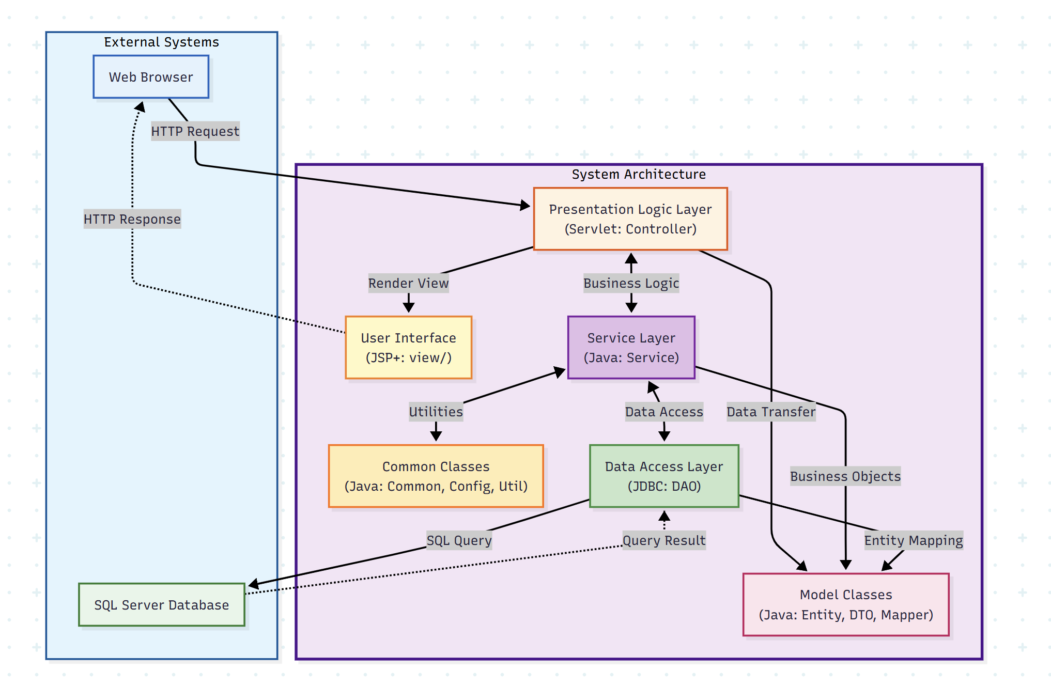

### **1.2 Component Descriptions**

| **No** | **Component** | **Description** |
| --- | --- | --- |
| *01* | *Presentation Logic Layer*  *(Servlet: Controller)* | *This layer handles incoming HTTP requests from clients and acts as the controller in the MVC pattern. It includes Servlets such as AuthControllerServlet (authentication), ProductControllerServlet (product management), OrderControllerServlet (order management), UserControllerServlet (user management), CartControllerServlet (cart operations), PaymentServlet (payment processing), SettingControllerServlet (system settings), CustomerServlet (customer profile), DashBoardCashierServlet (cashier dashboard), and CartApiServlet (REST API). Responsibilities include receiving requests, extracting parameters, calling appropriate service methods, handling exceptions, and forwarding responses to views or sending JSON responses. It validates user input and manages request/response flow* |
| *02* | *User Interface (JSP+: view/)* | *This layer is responsible for rendering the user interface using JavaServer Pages (JSP) with JSTL. It includes JSP files organized in directories such as home/ (public pages), auth/ (login/register), dashboard/ (Admin, HR, Marketer, Cashier dashboards), product/ (product management), order/ (order management), user/ (user management), promotion/ (promotion management), setting/ (settings management), and customer/ (customer profile). The UI layer receives data from controllers, formats it for display using Bootstrap and JavaScript, and generates HTML responses sent back to clients. It handles presentation logic, form rendering, and user interaction feedback.* |
| *03* | *Service Layer (Java: Service)* | *This layer contains the business logic of the application. It includes services such as UserService (user management, authentication, password handling), ProductService (product business logic, inventory management), OrderService (order processing, calculations, status management), PromotionService (promotion business logic, date validation), SettingService (system settings management), and OrderItemService (order item operations, quantity calculations). The Service Layer processes business rules, validates data according to business requirements, coordinates transactions, transforms data between layers using DTOs, and handles complex business operations. It acts as an intermediary between controllers and data access layer.* |
| *04* | *Data Access Layer (JDBC: DAO)* | *This layer handles all interactions with the database using JDBC and implements the DAO (Data Access Object) pattern. It includes DAOs such as UserDao (user CRUD operations), ProductDao (product CRUD operations), OrderDao (order CRUD operations), OrderItemDao (order item operations), PromotionDao (promotion CRUD operations), SettingDao (settings CRUD operations), and CartDao (cart operations). Responsibilities include managing database connections through DBConnect, executing SQL queries using PreparedStatement, mapping result sets to Entity objects, handling transactions, and performing CRUD operations. It abstracts database-specific details from the business logic layer, making it easy to switch database implementations.* |
| *05* | *Model Classes (Java: Entity, DTO, Mapper)* | *This component represents the data structures used throughout the application. It includes Entity classes (User, Product, Order, OrderItem, Promotion, Setting, Payment) that represent database tables and business objects. DTO (Data Transfer Object) classes (UserDto, ProductDto, OrderDto, OrderItemDto, PromotionDto, SettingDto, PaymentDto) for transferring data between layers without exposing internal structure. Mapper classes (UserMapper, ProductMapper, OrderMapper, PromotionMapper, SettingMapper, PaymentMapper) for converting between Entity and DTO objects. This separation ensures clean data representation, reduces coupling between layers, and maintains separation of concerns.* |
| *06* | *Common Classes (Java: Common, Config, Util)* | *This component contains shared utility classes and configuration classes used across the application. It includes common classes such as UserRole (role constants), PasswordUtils (password generation and validation), ValidationUtils (input validation), ErrorCodes (error code constants), Messages (message constants) for constants and utility functions. Configuration classes such as AppConfig (application configuration), PayOSConfig (PayOS payment gateway configuration), Routes (route definitions) for application settings. Utility classes such as EmailUtils (email sending) and GoogleUtils (Google OAuth integration) for external service integrations. These classes provide reusable functionality, maintain consistency across the application, and centralize configuration management.* |

### **1.3 External Systems**

| **No** | **Component** | **Description** |
| --- | --- | --- |
| *z01* | *Web Browser* | *The client-side application that users interact with. It sends HTTP requests to the Presentation Logic Layer and receives HTTP responses containing HTML pages rendered by the User Interface layer. Supports modern web browsers for accessing the Coffee Shop Management System.* |
| *02* | *SQL Server Database* | *The primary database system used for persistent data storage. It stores all application data including user information, products, orders, promotions, settings, and payment records. The Data Access Layer communicates with the database using JDBC to execute SQL queries, perform CRUD operations, and retrieve data.* |

## **2. Code Package Design**

*[Provide the package diagram for each sub-system. The content of this section including the overall package diagram, the explanation, package and class naming conventions in each package. Please see the sample & description table format below]*

### **2.1 Package Diagram**

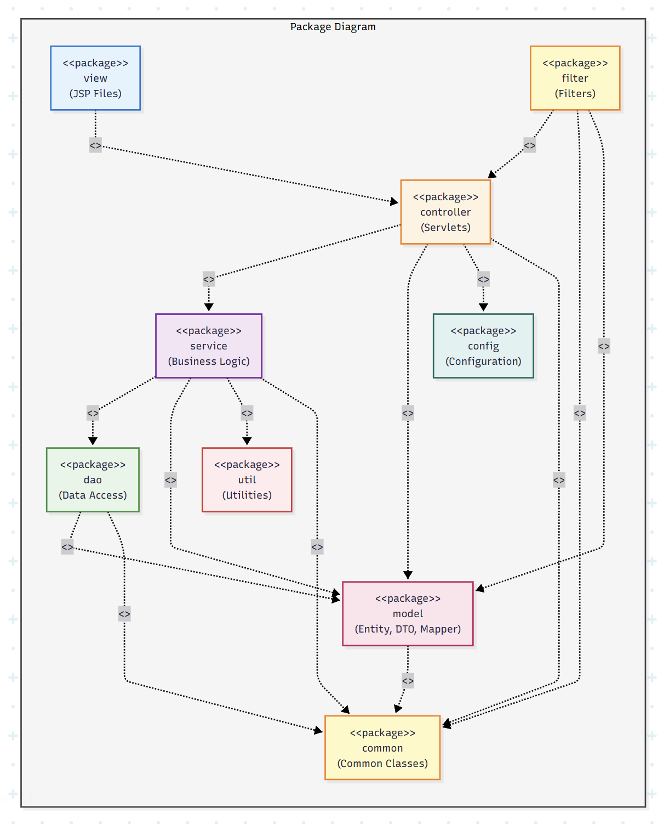

### **2.2 Package Descriptions**

| **No** | **Package** | **Description** |
| --- | --- | --- |
| *01* | *view (JSP Files)* | *Contains JSP files organized in directories such as home/, auth/, dashboard/, product/, order/, user/, promotion/, setting/, customer/. These JSP files render HTML responses using JSTL and Bootstrap. The view package displays data received from controllers and handles user interaction feedback.* |
| *02* | *controller (Servlets)* | *Contains Servlets that handle HTTP requests and act as controllers in the MVC pattern. Examples: AuthControllerServlet (authentication), ProductControllerServlet (product management), OrderControllerServlet (order management), UserControllerServlet (user management), CartControllerServlet (cart operations), PaymentServlet (payment processing), SettingControllerServlet (system settings), CustomerServlet (customer profile), DashBoardCashierServlet (cashier dashboard), CartApiServlet (REST API). This package processes requests, extracts parameters, calls services, handles exceptions, and forwards responses to views or sends JSON responses.* |
| *03* | *filter (Filters)* | *Contains Servlet Filters that handle cross-cutting concerns such as authentication, authorization, and character encoding. Examples: AuthFilter (validates user authentication and session), EncodingFilter (handles UTF-8 character encoding), RoleFilter (checks user roles and permissions). Filters intercept requests before they reach controllers and enforce security policies.* |
| *04* | *service (Business Logic)* | *Contains Service interfaces and implementations that contain business logic. Examples: UserService (user management, authentication, password handling), ProductService (product business logic, inventory management), OrderService (order processing, calculations, status management), PromotionService (promotion business logic, date validation), SettingService (system settings management), OrderItemService (order item operations, quantity calculations). This package processes business rules, validates data, coordinates transactions, and transforms data between layers.* |
| *06* | *dao (Data Access)* | *Contains Data Access Object (DAO) interfaces and JDBC implementations. Examples: UserDao (user CRUD operations), ProductDao (product CRUD operations), OrderDao (order CRUD operations), OrderItemDao (order item operations), PromotionDao (promotion CRUD operations), SettingDao (settings CRUD operations), CartDao (cart operations), and their JDBC implementations (UserDaoJdbc, ProductDaoJdbc, etc.). This package handles database connections through DBConnect, executes SQL queries using PreparedStatement, maps result sets to Entity objects, handles transactions, and performs CRUD operations.* |
| *07* | *model (Entity, DTO, Mapper)* | *Contains Entity classes, Data Transfer Objects (DTOs), and Mapper classes. Entity examples: User, Product, Order, OrderItem, Promotion, Setting, Payment (represent database tables and business objects). DTO examples: UserDto, ProductDto, OrderDto, OrderItemDto, PromotionDto, SettingDto, PaymentDto (transfer data between layers without exposing internal structure). Mapper examples: UserMapper, ProductMapper, OrderMapper, PromotionMapper, SettingMapper, PaymentMapper (convert between Entity and DTO objects). This package provides data structures used throughout the application.* |
| *07* | *common (Common Classes)* | *Contains shared utility classes and constants used across the application. Examples: UserRole (role constants: ADMIN, HR, MARKETER, CASHIER, CUSTOMER), PasswordUtils (password generation and validation), ValidationUtils (input validation), ErrorCodes (error code constants), Messages (message constants). This package provides reusable functionality, maintains consistency across the application, and centralizes constants and utility functions.* |
| *09* | *config (Configuration)* | *Contains configuration classes for application settings. Examples: AppConfig (application configuration), PayOSConfig (PayOS payment gateway configuration including API keys and endpoints), Routes (route definitions and URL mappings). This package manages application configuration, external service settings, and route mappings for controllers.* |
| *09* | *util (Utilities)* | *Contains utility classes for external service integrations and helper functions. Examples: EmailUtils (email sending functionality for verification and notifications using SMTP), GoogleUtils (Google OAuth integration for social login authentication). This package provides utilities for email communication, OAuth authentication, and other external service integrations.* |

## 

## 

## 

## 

## 

## 

## 

## 

## 

## 

## **3. Database Design**

*[Provide the files description, database table relationship & table descriptions like example below]*

### **3.1 Database Schema**

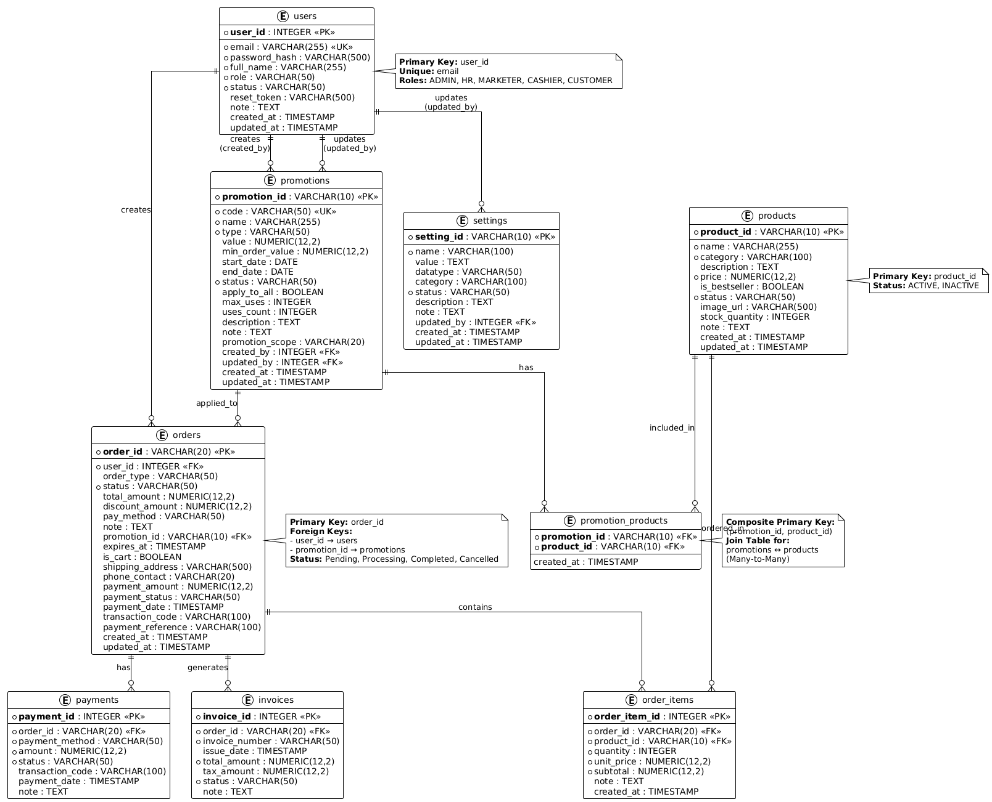

### 

### 

### 

### 

### 

### **3.2 Table Descriptions**

### **3.2.1 User**

Stores user accounts in the system (customers, staff, admin, cashier). Includes email, password, role, status, personal info, and loyalty points.

| **No** | **Field** | **PK** | **FK** | **UN** | **NN** | **Description** |
| --- | --- | --- | --- | --- | --- | --- |
| 01 | user_id |  |  | UN | NN | Primary Key. Auto-increment integer. Unique identifier for each user in the system. |
| 02 | email |  |  | UN | NN | User’s email address, used for login and communication. |
| 03 | password_hash |  |  |  |  | Hashed password for authentication (null if using Google login). |
| 04 | full_name |  |  |  |  | User’s full name. |
| 05 | phone |  |  |  |  | Contact phone number (unique if provided). |
| 060 | role |  |  |  | NN | User role in the system (customer, cashier, staff, admin, HR). |
| 07 | department |  |  |  |  | Department of the user (if staff/HR/admin). |
| 08 | status |  |  |  | NN | Account status (active/deactive). |
| 09 | google_id |  |  | UN |  | Google account ID if user logs in with Google. |
| 10 | loyalty_points |  |  |  | NN | Points accumulated by the customer for loyalty programs. |
| 11 | created_at |  |  |  | NN | Timestamp when the account was created. |
| 12 | updated_at |  |  |  | NN | Time of last update .If the account has not updated anything since creation, this entry will be recorded at creation time. |

#### **3.2.2 Product**

Stores basic product information: name, description, base price, status, bestseller flag, and category (coffee/tea/snack, etc.).

| **No** | **Field** | **PK** | **FK** | **UN** | **NN** | **Description** |
| --- | --- | --- | --- | --- | --- | --- |
| 01 | product_id | PK |  | UN | NN | Primary Key. Character varying(10). Unique identifier for each product. Format: P001, P002, etc. |
| 02 | name |  |  | UN |  |  |
| 03 | category |  |  |  | NN | Product category. Groups products by type (e.g., Coffee, Tea, Snacks, Desserts). |
| 04 | description |  |  |  |  | Product description. Detailed information about the product. |
| 05 | price |  |  |  | NN | Product price. Numeric(12,2). Price in currency units. Must be non-negative. |
| 06 | is_bestseller |  |  |  | NN | Best seller flag. Boolean. Default: false. Marks popular or featured products. |
| 07 | status |  |  |  | NN | Product status. Default: 'Activate'. Possible values: Activate, Deactivate. Controls product visibility. |
| 08 | image_url |  |  |  | NN | Product image URL. Path or URL to product image. Used for displaying product images. |
| 09 | stock_quantity |  |  |  | NN | Stock quantity. Integer. Default: 0. Current inventory count of the product. |
| 10 | note |  |  |  |  | Administrative notes. Optional notes about the product. |
| 11 | created_at |  |  |  | NN | Timestamp when product was created. Default: current timestamp. |
| 12 | updated_at |  |  |  | NN | Time of last update .If the account has not updated anything since creation, this entry will be recorded at creation time. |

#### 

#### 

#### 

#### 

#### 

#### 

#### 

#### **3.2.3 Order**

Manages product variations (e.g., size). Each variant has its own price and status.

| **No** | **Field** | **PK** | **FK** | **UN** | **NN** | **Description** |
| --- | --- | --- | --- | --- | --- | --- |
| 01 | order_id | PK |  |  | NN | Primary Key. Character varying(20). Unique identifier for each order. Format: ORD001, ORD002, etc. |
| 02 | user_id |  | FK |  | NN | Foreign Key. References users.user_id. Customer who placed the order. |
| 03 | order_type |  |  |  |  | Order type. Possible values: Dine-in, Takeaway, Delivery. Specifies how the order will be fulfilled. |
| 04 | status |  |  |  | NN | Order status. Default: 'Pending'. Possible values: Pending, Processing, Completed, Cancelled. Tracks order lifecycle. |
| 05 | total_amount |  |  |  | NN | Total order amount. Numeric(12,2). Default: 0. Sum of all items including discounts. |
| 06 | discount_amount |  |  |  | NN | Discount amount. Numeric(12,2). Default: 0. Total discount applied to the order. |
| 07 | pay_method |  |  |  |  | Payment method. Possible values: Cash, Online Banking, PayOS. Method used for payment. |
| 08 | note |  |  |  |  | Order notes. Special instructions or notes for the order. |
| 09 | promotion_id |  | FK |  |  | Foreign Key. References promotions.promotion_id. Promotion applied to this order. |
| 10 | expires_at |  |  |  |  | Order expiration timestamp. Timestamp when cart order expires. Used for cart timeout. |
| 11 | is_cart |  |  |  | NN | Cart flag. Boolean. Default: false. Indicates if this is a shopping cart or confirmed order. |
| 12 | shipping_address |  |  |  |  | Shipping address. Delivery address for takeaway/delivery orders. |
| 13 | phone_contact |  |  |  |  | Contact phone number. Phone number for order contact and delivery. |
| 14 | payment_amount |  |  |  |  | Payment amount. Numeric(12,2). Final amount paid for the order. |
| 15 | payment_status |  |  |  |  | Payment status. Possible values: Pending, Paid, Unpaid, Refunded. Tracks payment state. |
| 16 | payment_date |  |  |  |  | Payment date. Timestamp when payment was completed. |
| 17 | transaction_code |  |  |  |  | Transaction code. Payment gateway transaction reference code. |
| 18 | payment_reference |  |  |  |  | Payment reference. Additional payment gateway reference. |
| 19 | created_at |  |  |  | NN | Timestamp when order was created. Default: current timestamp. |
| 20 | updated_at |  |  |  | NN | Timestamp when order was last updated. Default: current timestamp. |

#### **3.2.4 Promotion**

Stores promotion/voucher campaigns: type, value, validity period, usage limits, status, and creator.

| **No** | **Field** | **PK** | **FK** | **UN** | **NN** | **Description** |
| --- | --- | --- | --- | --- | --- | --- |
| 01 | promotion_id | PK |  |  | NN | Primary Key. Character varying(10). Unique identifier for each promotion. Format: PRO001, PRO002, etc. |
| 02 | code |  |  | UN | NN | Unique. Promotion code. Character varying(50). Customer-entered code to apply promotion. Must be unique. |
| 03 | name |  |  |  | NN | Promotion name. Display name of the promotion. |
| 04 | type |  |  |  | NN | Promotion type. Possible values: percentage, fixed_amount, free_shipping. Determines discount calculation method. |
| 05 | value |  |  |  |  | Promotion value. Numeric(12,2). Discount amount or percentage depending on type. |
| 060 | min_order_value |  |  |  |  | Minimum order value. Numeric(12,2). Minimum order amount required to apply this promotion. |
| 07 | start_at |  |  |  |  | Start date. Date when promotion becomes active. |
| 08 | end_at |  |  |  |  | End date. Date when promotion expires. |
| 09 | status |  |  |  | NN | Promotion status. Default: 'Activate'. Possible values: Activate, Deactivate. Controls promotion availability. |
| 10 | apply_to_all |  |  |  | NN | Apply to all products. Boolean. Default: true. If true, applies to all products; if false, only to selected products. |
| 11 | max_uses |  | FK |  |  | Maximum uses. Integer. Maximum number of times this promotion can be used. Null means unlimited. |
| 12 | uses_count |  |  |  | NN | Uses count. Integer. Default: 0. Current number of times promotion has been used. |
| 13 | description |  |  |  |  | Promotion description. Detailed description of the promotion offer. |
| 14 | note |  |  |  |  | Administrative notes. Optional notes about the promotion. |
| 15 | promotion_scope |  |  |  |  | Promotion scope. Character varying(20). Additional scope classification for promotions. |
| 16 | created_by |  | FK |  |  | Foreign Key. References users.user_id. User who created this promotion. |
| 17 | updated_by |  | FK |  |  | Foreign Key. References users.user_id. User who last updated this promotion. |
| 18 | created_at |  |  |  | NN | Timestamp when promotion was created. Default: current timestamp. |
| 19 | updated_at |  |  |  | NN | Timestamp when promotion was last updated. Default: current timestamp. |

#### **3.2.5 Promotion_Products**

Junction table linking promotions to products they apply to.

| **No** | **Field** | **PK** | **FK** | **UN** | **NN** | **Description** |
| --- | --- | --- | --- | --- | --- | --- |
| 01 | promotion_id | PK | FK |  | NN | Part of Composite Primary Key. Foreign Key. References promotions.promotion_id. Promotion this product belongs to. |
| 02 | product_id | PK | FK |  | NN | Part of Composite Primary Key. Foreign Key. References products.product_id. Product included in this promotion. |
| 03 | created_at |  |  |  |  | Timestamp when the promotion-product link was created. Default: current timestamp. |

#### **3.2.6 Settings**

Stores system configuration parameters

| **No** | **Field** | **PK** | **FK** | **UN** | **NN** | **Description** |
| --- | --- | --- | --- | --- | --- | --- |
| 01 | setting_id | PK |  | UN | NN | Primary Key. Character varying(10). Unique identifier for each setting. Format: ST001, ST002, etc. |
| 02 | name |  |  | UN | NN | Setting name. Character varying(100). Unique name identifying the setting (e.g., 'shop_name', 'free_shipping_threshold'). |
| 03 | value |  |  |  |  | Setting value. Text. The actual value of the setting. Can be of various types depending on datatype. |
| 04 | data_type |  |  |  |  | Data type. Character varying(50). Type of the value: time_range, currency, percentage, email, number, string, json. |
| 05 | category |  |  |  |  | Setting category. Character varying(100). Groups settings by purpose: Operation, Delivery, Finance, Notification, Reservation, General. |
| 060 | status |  |  |  | NN | Setting status. Default: 'Active'. Possible values: Active, Deactive. Controls whether setting is active. |
| 07 | description |  |  |  |  | Setting description. Detailed description of what this setting controls. |
| 08 | note |  | FK |  |  | Administrative notes. Optional notes about the setting. |
| 09 | updated_at |  |  |  | NN | Foreign Key. References users.user_id. User who last updated this setting. |
| 10 | created_at |  |  |  |  | Timestamp when setting was created. Default: current timestamp. |
| 11 | updated_at |  |  |  |  | Timestamp when setting was last updated. Default: current timestamp. |

#### **3.2.7 Order_Items**

Stores product details within each order (quantity, unit price, line total). Includes product name/price snapshot at order time.

| **No** | **Field** | **PK** | **FK** | **UN** | **NN** | **Description** |
| --- | --- | --- | --- | --- | --- | --- |
| 01 | order_item_id | PK |  | UN | NN | Primary Key. Auto-increment integer. Unique identifier for each order item. |
| 02 | order_id |  | FK |  | NN | Foreign Key. References orders.order_id. Order this item belongs to. |
| 03 | product_id |  | FK |  |  | Foreign Key. References products.product_id. Product in this order item. |
| 04 | quantity |  | FK |  |  | Quantity ordered. Integer. Default: 1. Number of units of the product ordered. |
| 05 | unit_price |  |  |  | NN | Unit price. Numeric(12,2). Price per unit at time of order. Captured to preserve historical pricing. |
| 060 | subtotal |  |  |  | NN | Subtotal. Numeric(12,2). Calculated as quantity Ã— unit_price. Total for this line item. |
| 07 | note |  |  |  | NN |  |
| 08 | created_at |  |  |  | NN | Timestamp when order item was created. Default: current timestamp. |

#### **3.2.8 payments**

Links orders with applied promotions. Stores promo code and discount amount.

| **No** | **Field** | **PK** | **FK** | **UN** | **NN** | **Description** |
| --- | --- | --- | --- | --- | --- | --- |
| 01 | payment_id | PK |  |  | NN | Primary Key. Auto-increment integer. Unique identifier for each payment transaction. |
| 02 | order_id |  | FK |  | NN | Foreign Key. References orders.order_id. Order this payment is for. |
| 03 | payment_method |  |  |  | NN | Payment method. Character varying(50). Method used: Cash, Online Banking, PayOS, etc. |
| 04 | amount |  |  |  | NN | Payment amount. Numeric(12,2). Amount paid in this transaction. |
| 05 | status |  |  |  | NN | Payment status. Character varying(50). Possible values: Pending, Completed, Failed, Refunded. Tracks payment state. |
| 06 | transaction_code |  |  |  |  | Transaction code. Character varying(100). Payment gateway transaction reference code. |
| 07 | payment_date |  |  |  | NN | Payment date. Timestamp. Default: current timestamp. When payment was processed. |
| 08 | note |  |  |  |  | Payment notes. Additional notes or comments about the payment. |

#### **3.2.8 invoices**

Stores payment details for orders: amount, method (cash, card, e-wallet), status, transaction reference, and payment time.

| **No** | **Field** | **PK** | **FK** | **UN** | **NN** | **Description** |
| --- | --- | --- | --- | --- | --- | --- |
| 01 | invoice_id | PK |  | UN | NN | Primary Key. Auto-increment integer. Unique identifier for each invoice. |
| 02 | order_id |  | FK |  | NN | Foreign Key. References orders.order_id. Order this invoice is generated from. |
| 03 | invoice_number |  |  |  | NN | Foreign Key. References orders.order_id. Order this invoice is generated from.  Invoice number. Character varying(50). Unique invoice number for official records. Format: INV001, INV002, etc. |
| 04 | issue_date |  |  |  | NN | Foreign Key. References orders.order_id. Order this invoice is generated from.  Invoice number. Character varying(50). Unique invoice number for official records. Format: INV001, INV002, etc.  Issue date. Timestamp. Default: current timestamp. Date when invoice was issued. |
| 05 | total_amount |  |  |  | NN | Total amount. Numeric(12,2). Total invoice amount including all items and taxes. |
| 060 | tax_amount |  |  |  | NN | Tax amount. Numeric(12,2). Default: 0. Tax portion of the total amount. |
| 07 | status |  |  |  | NN | Invoice status. Character varying(50). Possible values: Draft, Issued, Paid, Cancelled. Tracks invoice state. |
| 08 | note |  |  |  | NN | Invoice notes. Additional notes or comments on the invoice. |